**Biological Influences**

Brain

Thursday, January 31, 2019

8:49 AM

|  |  |
| --- | --- |
| Frontal Lobe | Broca's Area:  Located in the left frontal lobe close to the primary motor cortex, Broca's area directs the area of the primary motor cortex that controls muscles of the mouth, jaw, tongue and face. By controlling the movement of these muscles, Broca's area is primarily responsible for the production of articulate (clear and fluent) speech. It is also involved in the structure of sentences and analyzing the grammar of sentences. If Broca's area is damaged, a person may be unable to produce clear and articulate speech.    Broca's Aphasia - Language comprehension is retained but language formulation is found difficult. Patients can relearn how to speak by singing words as singing uses the right side - Broca's area is on the left so it allows for them to speak via singing, thus being able to teach the other hemisphere to talk.    Primary Motor Cortex:  An area at the rear of the frontal lobe that directs the body's skeletal muscles and controls voluntary movement. The right hemisphere of the primary motor cortex controls the left side of the body's voluntary movement, and the left hemisphere of the primary motor cortex controls the voluntary movement of the right side of the body. |
| Parietal Lobe | Primary Sensory (Somatosensory) Cortex:  The primary somatosensory cortex is a strip of neurons that is located at the front of the parietal lobe, adjacent to the primary motor cortex. Sensations that are detected in the sensory receptors located throughout the body and the skin are registered and processed in the somatosensory cortex. As a result of this we feel a sensation and can form a perception of what it is and where it came from.    Sensory information from the left side of the body travels, in the first instance, to the somatosensory cortex of the right hemisphere's parietal lobe. Sensory information from the right side of the body travels first to the somatosensory cortex of the left hemisphere's parietal lobe. |
| Temporal Lobe | Wernicke's Area:  Wernicke's area (identified by Carl Wernicke) is located for 95% of people in the left hemisphere of the temporal lobe, and in the right hemisphere for the other 5%. It is located near the primary auditory cortex and it is connected to Broca's area by nerve fibres. Wernicke's area is the cortical area believed to be responsible for accessing words store in the memory; therefore, it is believed to be responsible for the comprehension of speech and the formulation of meaningful sentences (Gardner & Gardner, 1978).  The sounds associated with speech initially register in the primary auditory cortex of both hemispheres. However, the information must then be transferred to association areas in the left temporal lobe and processed by Wernicke’s area if they are to be identified as words and their meaning understood.  Because Wernicke’s area is thought to be involved in locating words stored in memory, damage to the temporal lobe can severely limit the ability to understand and use language, people who have damage to Wernicke's area can produce fluent speech that is meaningless or gibberish.    Wernicke's Aphasia - fluent speech is retained but it is meaningless or gibberish, language comprehension is affected.    Primary Auditory Cortex:  Is the area of the temporal lobe that registers and processes auditory information. If we were to stimulate the auditory area o the temporal lobe, our subject would 'hear' a series of sound sensations. Additionally, different parts of the auditory cortex respond to a different pitch.  The auditory cortex in the right temporal lobe is specialized to process non-verbal sounds, whilst the auditory cortex in the left temporal lobe is specialized to process verbal sounds that are associated with language. |
| Occipital Lobe | Primary Visual Cortex: The primary visual cortex is an area at the base of the occipital lobe that registers and processes visual information transmitted from the retinas of bot eyes. The optic nerves, which leave the back of the retina and connect with neurons in the primary visual cortex, provide the neural pathway along which this information travels. Information from the right visual field of each eye is transmitted to the primary visual cortex in the left occipital lobe, and any information from the left visual cortex is received in the right occipital lobe. |

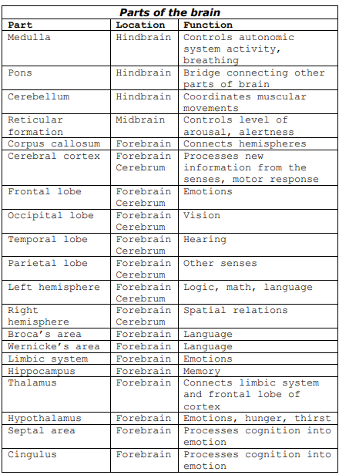

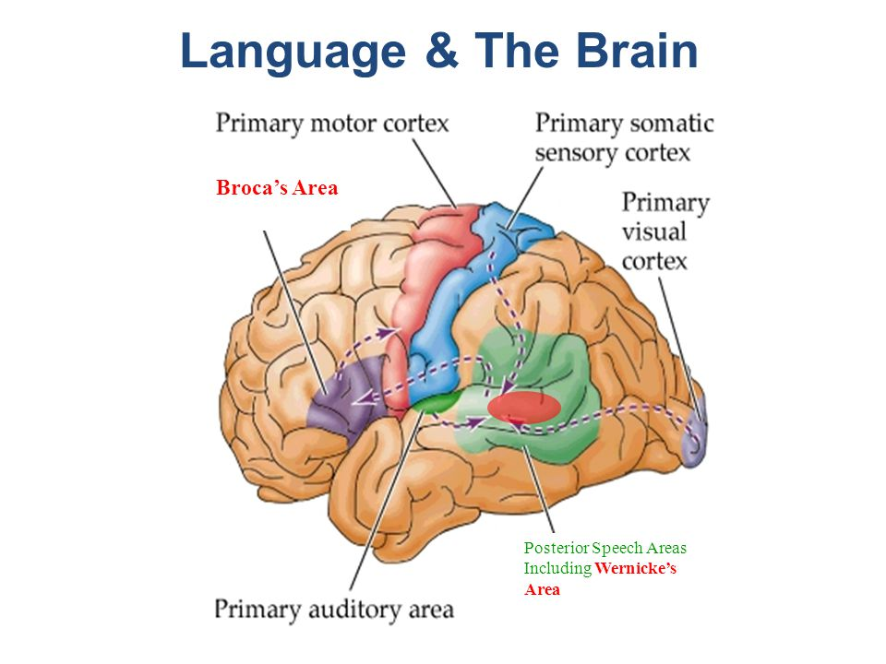

K

CNS & PNS

Wednesday, February 6, 2019

2:27 PM

**Central Nervous System (CNS):**

**Brain:**

* it receives and processes information from the rest of the body and generates responses to it
* The brain can be seen as the engine room of the nervous system
* The nervous system is a complex structure composed of billions of neurons

**Spinal Cord:**

* The spinal cord is an intricate and delicate cable of nerve fibres stretching from the base of the brain to the lower back, connecting the brain to the rest of the body via its connects to the Peripheral nervous system (PNS)
* The spinal cord transmits information from the PNS up to the brain for processing
* The spinal cord receives information (motor messages) from the brain and transmits it to the PNS and therefore the rest of the body
* If the spinal cord is damaged it can result in the flow of information being lost causing either a loss of sensation in a certain body part or the inability to move that body part (paraplegics & quadriplegics)

**Peripheral Nervous System (PNS):**

* The peripheral nervous system consists of all o the nerves that are outside the CNS
* The role of the PNS is to carry sensory information from the rest of the body to the CNS and motor information from the CNS to the rest of the body.
* An example of the way the PNS and CNS work together is when you are running a shower and put your hand under the water to test the temperature. Sensory neurons in your skin register the temperature, and that information is then transmitted by the PNS to the spinal cord and then finally to the brain. The brain then determines whether more hot or cold water needs to be added, the brain then sends these motor messages via the spinal cord and PNS to your hand

**Somatic Nervous System:**

* Has a sensory and motor role
* The sensory role consists of receiving sensory information from receptor cells located throughout the body and transmitting it inwards to the spinal cord.
* The motor role is the control of voluntary movement through its control of skeletal muscles (muscles attached to bones), it receives motor messages from the CNS ad transports them to skeletal muscles in specific body regions so that our responses to stimuli are appropriate (putting on a jumper when its cold)

**Autonomic Nervous System:**

* The autonomic nervous system contains nerves that are connected to the CNS and the involuntary muscles that control the activity level of our internal organs and glands
* By relaying messages between the CNS and our internal systems, the autonomic nervous system controls all the body's involuntary internal activities that are essential to survival. These activity include heart rate, digestion, kidney function, liver function, glandular activity and perspiration levels.
* You can shade your eyes from the sun, this is voluntary and this is controlled by the somatic nervous system, but your eyes constrict of your pupils to limit the amount of light entering the eye is, which is controlled by the autonomic nervous system.

**Sympathetic Nervous System:**

* This branch of the ANS that dominates during times of high emotion or intense physical activity, the sympathetic nervous system mobilizes the body's internal resources to provide the extra energy we need for vigorous action, especially in times of stress or threat.
* The sympathetic nervous system changes the activity levels of our internal systems so we have a sudden increase in our energy levels when needed.
* "Flight or Fight responses"
* If we stay in our accelerated state for too long then we start to experience stress

**Parasympathetic Nervous System:**

* Once the need for high arousal has passed, the parasympathetic nervous system reverses the effects of the sympathetic nervous system
* This reversal returns our body to its normal level of arousal, or a more relaxed state that is appropriate when the period of high emotion or need for physical activity has passed
* Our heart and breathing rates, the level of sugar and fats in our bloodstream, the size of our pupils, our blood pressure and digestion rate and so on return to normal levels of activity
* Homeostasis: refers to our balanced and healthy state and is the state that we spend most of our time enjoying
* Still takes time to calm down(20-30 minutes sometimes)

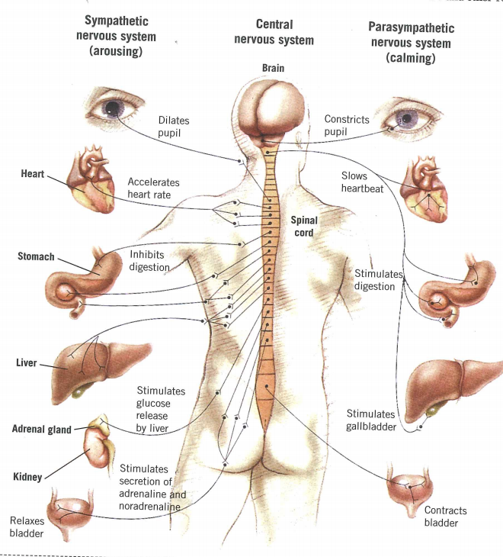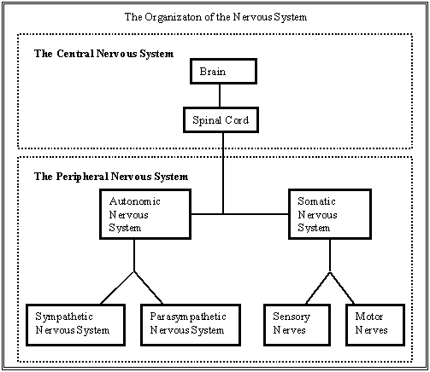

Neuron & Neurotransmitters

Tuesday, February 12, 2019

1:56 PM

**Neurotransmitters: Travel through nervous system (fast)**

Dopamine:

* Excitatory
* Responsible for motor control, attention, and pleasure
* Low levels of dopamine can cause Parkinson's
* Link between low levels of dopamine and addiction and possible link between low levels of dopamine and ADHD
* High levels of dopamine possibly causes Schizophrenia

Serotonin:

* Excitatory
* Responsible for many neurological functions, including regulating mood, sleep, and aggression
* Link between serotonin levels and depression
* Most antidepressant medications are SSRI's (Selective serotonin reuptake inhibitor) which block the reabsorption of serotonin into the brain

**Role of the Synapse:**

Synapse is the area where two neurons com close enough to one another that they are able to pass chemical signals from one cell to another.

The neurons are not actually connected, but are separated by a microscopically small space called the synaptic cleft

Neurotransmitters are released into the synaptic cleft and are absorbed into the receptors of the receiving cell and continues the process by creating a new action potential in the new neuron

Any neurotransmitters that aren't received by the receptors of the post-synaptic neuron are

either recycled back into the pre-synaptic neuron, drift away in a process called diffusion, or be broken down by enzymes.

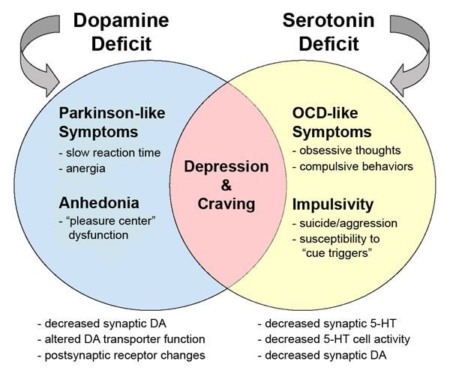

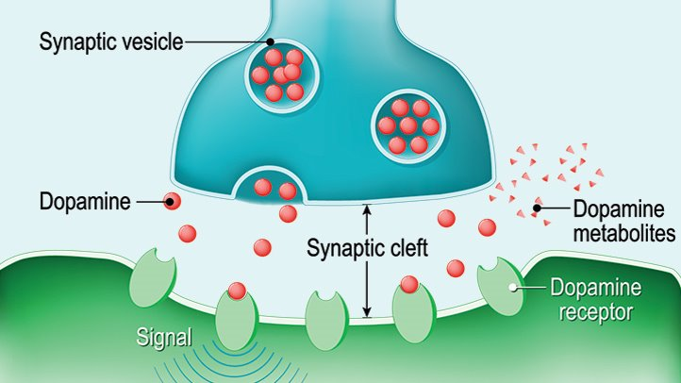

Heredity & Hormones

Wednesday, February 13, 2019

10:11 AM

Factors that affect behaviors, emotion and though:

* Heredity
* Passing of traits from one generation to another
* Genes - one pair from mother, one pair from father
* Genes provide: Traits, instructions for cell differentiation and growth, and receptors for neurotransmitters
* Epigenetics - expression of gene is affected by environmental influences
* Hormones (travel through the blood (slow))
* Adrenaline:

Transmitter substance for the sympathetic nervous system

Increases: Blood flow to muscles, pupil dilation, output of the heart, and blood sugar

Suppresses: Reproductive system, digestive system, and immune system

Controls flight or fight response

Too much adrenaline causes anxiety

* Noradrenaline:

Synthesized from dopamine

Causes alertness/arousal

Influences reward system

Enhances memory retrieval

Increases: heart rate, blood sugar, pupil dilation

Decreases: Digestive system, and reproductive system

* Hormones: they also function as neurotransmitters but are renamed and epinephrine and norepinephrine, and mimic the stress response of the sympathetic nervous system
* Psychoactive Drugs - substances that act on the nervous system to alter the state of consciousness, modify perceptions, and change moods
* Stimulants - increase the activity of the CNS, increase blood pressure, heart rate, appetite and leads to

Nicotine

Caffeine

Cocaine

Amphetamines

Methamphetamine

* Depressants - Calms the activity of the nervous system and slows the body's functions

Alcohol

Oxycodone

Heroine

Analgesics

Benzodiazepines

Cannabis

Morphine

Marijuana

* Hallucinogens - changes perceptions and gives sensory images without input from the senses

Causes trance-like state, excitation, euphoria, insomnia, hallucinations, paranoia

Disrupts the interaction of serotonin and nerve cells

There is a debate over its addiction potentiality

Debate over being a stressor in diathesis-stress for schizophrenia

LSD

Peyote

Marijuana

Ecstasy

Magic mushroom

Designer drugs (MDMA, XTC)

Behavior - Actions

Emotions - Anger, sadness, happiness etc

Thoughts - lead to emotions

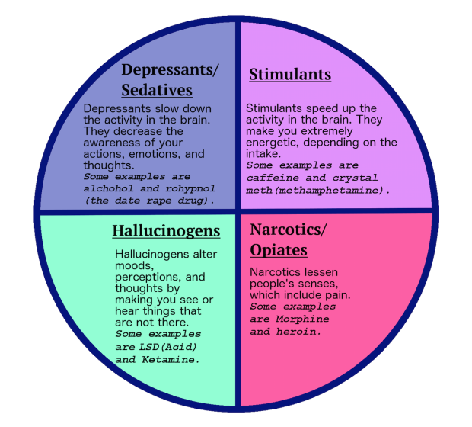

**Memory & Forgetting**

Memory

Thursday, February 28, 2019

9:16 AM

Models of memory

* Multi-store model (Atkinson & Shiffron (1968))
* Maintenance and elaborative rehearsal
* Serial-position effect
* Chunking
* Working memory model (Baddeley and Hitch (1974))
* Phonological loop
* Visuospatial sketchpad
* Central executive

Memory formation

* Consolidation Theory

Long Term Memory

* Memory types
* Semantic network theory

**Memory -** an active information-processing system that receives, stores, organizes and recovers information.

**Encoding** - the process that converts information into a usable form (code) that can be stored and represented in the memory system.

**Storage** - The retention of information in the memory system over time.

**Retrieval** - the process of locating information stored in the memory and bringing it into consciousness when needed, to complete a cognitive task.

**Atkinson & Shiffrin (1968)**

Atkinson and Shiffrin proposed that the memory consisted of three stores: a sensory register, short term memory and long term memory.

Information passes from store to store in a linear way, and has been described as an information processing model with an input, process and output.

Information is detected by the sense organs and enters the sensory memory. If attended to this information enters the short term memory.

Information from the short term memory is transferred to the long-term memory only if that information is rehearsed.

If maintenance rehearsed does not occur, the information is forgotten, and lost from the short term memory through the process of displacement or decay.

**The Memory Stores:**

Each store is a unitary structure and has its own characteristics in term of encoding, capacity and duration.

Encoding - the way information is changed so that it can be stored in the memory. There are three main ways in which information can be encoded.

1. Visual (picture)
2. Acoustic (sound)
3. Semantic (meaning)

Capacity - concerns how much information can be stored

Duration - refers to the period of time information can last in the memory stores.

**Sensory Memory:**

Duration - 1/4 to 1/2 a second

Capacity - all sensory experience

Encoding - sense specific

**Short Term Memory:**

Duration - 0-18 seconds

Capacity - 7 +/- 2 items

Can be increased beyond the usual 7 +/- 2 items by chunking - which is grouping separate information items into larger single information units to effectively increase the capacity of the short term memory.

Encoding - mainly auditory

**Long Term Memory:**

Duration - Unlimited

Capacity - Unlimited

Encoding - Mainly semantic (but can be visual and auditory)

**Baddeley & Hitch (1974):**

Baddeley and Hitch argue that the picture of short term memory provided in the multi-store model is far too simple. According to the multi-store model the short term memory holds limited amounts of information for short periods of time with relatively little processing. It is a unitary system meaning that it is a single system without any subsystems. Working memory is not a unitary store.

Working memory replaces the short-term memory in Baddeley and Hitch's model. The working memory is the short term memory but it has multiple systems for different types of information.

Maintenance rehearsal - remembering something for immediate usage

Elaborative rehearsal - actively process and encode info for retrieval later

**Central Executive:**

Drives the whole system and allocates data to the subsystems: the phonological loop and the visuospatial sketchpad. It also deals with cognitive tasks such as metal arithmetic and problem-solving.

It is the most important component of the model although little is really known about how it functions. It is responsible for coordinating and monitoring the operation of the slave systems and relates the to the long term memory. The central executive decides which information is attended to and which parts of the working memory to send that information to be dealt with. For example, two activities sometimes come into conflict such as driving a car and talking. Rather than hitting a cyclist on the road who is wobbling all over the place the central executive directs and gives priority to concentrating on driving rather than talking.

**Visuospatial Sketchpad (inner eye):**

Stores and processes information in a visual or spatial form. The visuospatial sketchpad is used for navigation.

Visual information refers to what things look like and it is highly likely that the visuospatial sketchpad plays an important role in helping us keep track of where we are in relation to other objects as we move through our environment. The sketchpad also displays and manipulates visual and spatial information held in long-term memory. For example, the spatial layout of your house is held in the long-term memory. Try answering this question: How many windows are there in the front of your house?  You probably find yourself picturing the front of your house and counting the windows. An image has been retrieved from LTM and pictured on the sketchpad.

**Phonological Loop:**

Part of the working memory that deals with spoken and written materials. It can be used to remember a phone number. It consists of two parts.

1. **Phonological Store:** (inner ear) - linked to speech perception, holds information in a speech-based form (i.e., spoken words) for 1-2 seconds.
2. **Articulatory control process:** (inner voice) - Linked to speech production. Used to rehearse and store verbal information from the phonological store.

The phonological store acts as an inner ear and holds information in a speech based form for 1-2 seconds. Spoken words enter the store directly. Written words must first be converted into an articulatory (spoken) code before they can enter the phonological store.

The articulatory control process acts like an inner voice rehearsing information round and round like a tape loop. This is how we remember a telephone number we have just heard. As long as we keep repeating it, we can retain the information in the working memory. The articulatory control process also converts written material into an articulatory code and transfers it to the phonological store.

**Strengths of both models**

**Multi-store model (Atkinson & Shiffrin 1968)**

* lots of evidence for differentiating short term memory and long term memory in regard to capacity, duration and encoding.
* Supported by the studies of amnesiacs
* Accounts for primacy and recency effects
* Generated lots of future research

**Working Memory (Baddeley & Hitch 1974)**

* Supported by experimental evidence
* Working memory is supported by dual task studies
* Doesn’t overemphasize the Short term memory to the long term memory through rehearsal (mistake of prior model)

**Weaknesses of both models**

**Multi-store model (Atkinson & Shiffrin 1968)**

* Oversimplified
* Long-term and short-term memory are more complicated than first though (seen through Baddeley and Hitch 1974)
* Suggests rehearsal is essential yet sometimes we remember things we never rehearsed
* Unaccounted for

**Working Memory (Baddeley & Hitch 1974)**

* Suggests the visuospatial sketchpad implies all spatial info, yet blind people have great spatial awareness
* Little evidence for how the central executive works
* Only involves short-term memory so it isn't a complicated model of memory (leaves out long term memory)

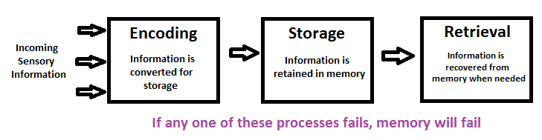

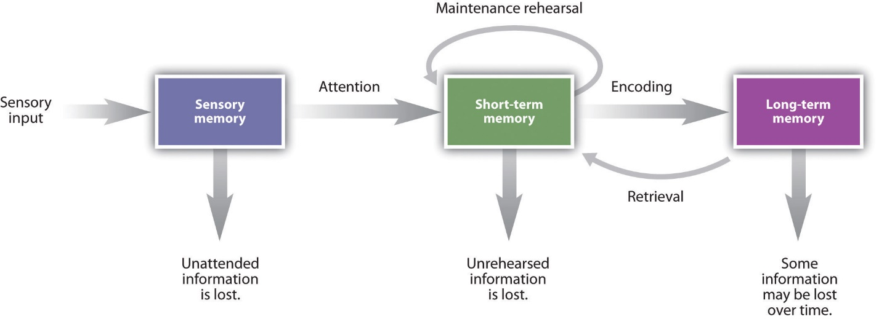

Working Memory Model (Baddeley and Hitch, 1974) 
Visuo-spatial scratch pad 
Attention 
Sensory 
memory 
Decay 
Central 
Executive 
Phonological Loop 
Arti culatory control 
Phonological store 
Long-Tenn 
Memory• 
Fig 2. The Working Memory Model Components (Baddeley and Hitch, 1974) 

Organization of information in the long - term memory:

Information in the long-term memory is organized on the basis of meaning (semantically)

Long term memories are divided into two different memory types, procedural and declarative

Declarative memories can be divided further into semantic or episodic memories.

Information in the long-term memory is stores in an interrelated hierarchy of concepts linked by meaning (animal hierarchy thing)

Concepts close in meaning have shorter links and are easier to retrieve.

Craik and Lockhart suggest that after information leaves sensory memory its storage varies along a continuum of processing levels ranging from shallow processing to deep processing, and the level of processing used during encoding determines how long and how well information is stored.

Forgetting

Thursday, March 7, 2019

2:05 PM

**Forgetting:** difficulty accessing or retrieving memories, when you forget something you just cannot find it when you want to.

**Retrieval Failure Theory:** suggests that many memories are inaccessible because memory cues were present at the time when the memory was formed are not present at the time that you are trying to recall them. The information isn't lost, it's just that we simply cannot find the correct cues to trigger the recall of the memory. For example if you were asked what happen on a specific date a few years ago you may not immediately remember what happened, but if you were told something like "that was the day you broke your leg" then you would be able to remember what happened that day, because the appropriate cue was presented.

Other types of cues are; context dependent cues, state dependent cues.

**Tip of the tongue phenomenon:**

When we experience the tip of the tongue phenomenon, we have some of the information about the word that we want - sometimes even the number of syllables or the words first letter - but we cannot come up with the word itself. As we retrieve information in bits, sometimes not all the bits are retrieved leaving us with incomplete recall.

**Interference theory:**

Sometimes when we recall specific information from the long-term memory, we experience difficulty because other memories get in the way of the one that we are trying to recall. When this happens, we experience what is called the interference theory. It refers to the tendency for pre-existing memories, either new or old to interfere with the recall of a required memory. For example, if you learnt a language in junior school then went to learn a different language in high school, the new knowledge from the new language will interfere with the pre-existing words already in your memory.

Retroactive Interference: refers to the tendency for new information to obstruct the retrieval of previously learnt information. Prefix *retro* means going backwards (causing difficulty to retrieve older information - learnt back in time).

Proactive Interference: refers to the tendency for previously learnt information obstructs the retrieval of newly learnt information. Prefix *pro*  means forward in time (causing difficulty learning new information - learnt forward in time).

**Motivated Forgetting:** inability to remember due to an advantage or benefit gained by not remembering.

Repression: unconsciously forgetting information to protect the person from negative connotations that may occur from them.

Suppression: deliberately trying to forget information that may be painful to attempt to protect themselves from negative feelings that may occur from it.

**Decay:** Simply the fading of information over time.

**Enhancing retrieval of info + improving memory:**

The ways memory can be improved

1. Improved organization of memory
2. Pay closer attention to the desired info
3. Having experience with the info
4. Rehearsing the info (goes from working memory to the long-term memory)

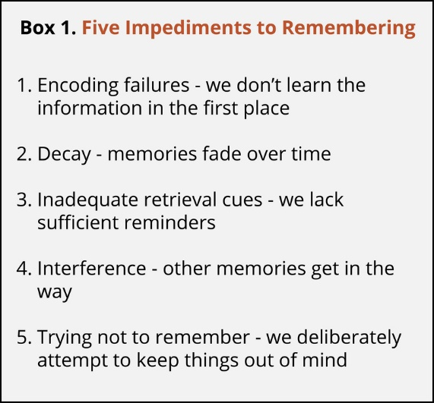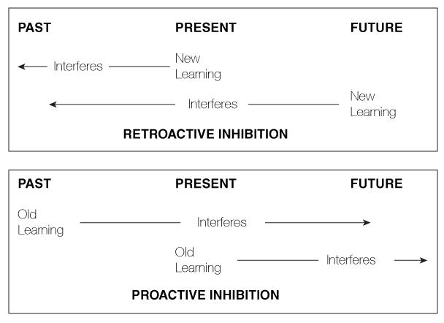

Conditioning

Tuesday, April 2, 2019

12:12 PM

**Classical Conditioning:**

* **Learning through association**

**Terminology**

Unconditioned stimulus - natural stimuli that causes a natural response, for example the stimuli could be a piece of meat that causes the natural response of salivation (pavlov's dog)

Neutral Stimulus - No response by itself

Conditioned stimulus - artificially introduced stimulus that causes a natural response (began as the neutral stimulus and turns the natural response into a conditioned response)

**Stages - Reference to Pavlov's doggo**

**Before conditioning**

* Neutral stimulus (bell) -> No response
* Unconditioned Stimulus (food) -> unconditioned response (salivation)

**During conditioning**

* Neutral stimulus (bell) + Unconditioned stimulus (food) -> unconditioned response (salivation)

**After conditioning**

* Conditioned stimulus (bell) -> conditioned response (salivation)

**Little Albert**

* Little albert was conditioned to have a phobia of white rats (due to pairing with a loud bang behind him and the response of crying to the bang)

**Further Notes**

* The strength of the conditioned response can reduce -> the extinction of the conditioned response
* "Spontaneous recovery" may occur after a pause of time then exposing them to the conditioned response
* Stimulus generalization may occur (eg Pavlov's dog salivating at bells, the salivating to buzzers)
* Applications - Gradual Exposure and systematic desensitization

**Operant conditioning:**

* **Learning through consequences**

By presenting a rewards, Skinner trained rats and pigeons to perform voluntary acts (skinner box)

Three phase model: Discriminatory stimulus -> behavior -> consequences

The Skinner box -> response desired (pressing a button or spot inside the box), rewards (food dispenser) and punishment (electric floor)

**Reinforces: Strengthens the chances of a behavior being replicated/increases the likelihood of a desired response.**

Positive Reinforcement - give something to act as a reward for completing the desired behavior (ie food in the skinner box for doing the desired action)

Negative Reinforcement - taking something away that may cause discomfort to the subject as a form of reward for completing the desired behavior (losing the mouthpiece on a horse or letting a dog off the leash for being a good boi)

**Punishment: Weakens the chances of a behavior being replicated/decreased the likelihood of a desired response.**

Positive Punishment - giving something as a form of punishment (smacking a child for being naughty, teaches them to not do it again)

Negative Punishment - taking something away as a form of punishment (taking away a toy or game console for being naughty, teaches them to not do it again)

**Methods of partial reinforcement**

**Best -** Variable ratio reinforcement - positively reinforcing a behavior after an unknown amount of times the behavior is repeated (high response rate: low extinction rate), ie buying 8 coffees to get one free etc etc

**Worst -** continuous reinforcement - Positive reinforcement **every** time the behavior occurs (slow response rate: High extinction rate)

**Observational Learning -** Possible to learn behaviors through observing other people actions and their consequences

* Based on who you see as a model

The **Mediation** process concerns whether or not the person picks up the behavior

* Input (environment) -> Mediation -> Output (behavior)

The process has five factors

1. Attention (notice behavior)
2. Retention (accurately remember behavior)
3. Reproduction (ability to reproduce the behavior)
4. Motivation (motivation to repeat it)
5. Reinforcement (how much the behavior is reinforced by the consequence)

**Bandura's Bobo doll experiment (1961)**

* Children copy the aggressive behaviors that they have seen modelled (demonstrated that kids didn’t need to engage in a behavior to learn it)

**STRENGTHS AND WEAKNESSES // EFFECTIVENESS**

**Classical conditioning**

**Strengths**

* Practical
* Creates useful life skills (fear of dangerous stuff)

**Weaknesses**

* Cannot create 'real behaviors'
* Can create negative phobias (little albert)

**Operant conditioning**

**Strengths**

* Easier to apply than classical conditioning
* Supported by research (skinner box)
* Generalized to humans, even in cases of deficiencies such as autism

**Weaknesses**

* Doesn’t always work - a person who has been punished learns how to avoid punishment (skinner on how behavior may not cease, just become smarter)
* No emphasis on cognition (motivation not considered)

**Observational Learning**

**Strengths**

* Emphasizes on cognition
* Easy to understand

**Weaknesses**

* Assumes nurture > nature
* Contestable

**Token Economies:**

A form of behavior modification designed to increase desirable behavior and decrease undesirable behavior with the use of some form of **tokens.** Individuals receive tokens immediately after displaying desirable behavior, the tokens are later collected and later exchanged for a meaningful object or privilege. (For example, stars on a board for handing in practice responses and the person with the most stars at the end of the term gets a reward of some kind.)

Phobias

Phobias created through classical conditioning (association) and observational learning

Maintained through operant conditioning (person who is afraid of something will tend to try and distance themselves from the thing that they are afraid of) which is negative (taking) reinforcement (something that makes you feel bad) which increases the behavior and the phobia.

CBT and systematic desensitization are two ways to treat phobias. Can be used as separate techniques or together.

Beck (1967) - CBT

McGrath et al (1990) - Supporting SD

Watson (1920) - Little albert

Wolpe (1950's) - behavioral therapy, systematic desensitization and precursors to today's fear reduction techniques

BF Skinner (1950's) - radical behaviorism and operant conditioning

Lewinsohn (1981) - studied a group of people before they became depressed, and suggested that negative thoughts are more of a side effect than a cause of depression.

Butler & Beck (2000) - support CBT

Thursday, April 4, 2019

2:22 PM

**Phobias:**  are an extreme, irrational fear of a specific object or situation. A phobia is classified as a type of anxiety disorder, since anxiety is the chief symptom experienced by the sufferer. Phobias are thought to be learned emotional responses.

It is generally held that phobias occur when fear produced by an original threatening situation is transferred to other situations, with the original fear often repressed or forgotten. An excessive, unreasoning fear of water.

For example may be based on a forgotten childhood experience of almost drowning. The person accordingly tries to avoid that situation in the future, a response that, while reducing anxiety in the short-term, reinforces the person's association of the situation with the onset of anxiety.

Phobias caused by classical conditioning (most) associating the response of fear with an object or situation. Whilst phobias caused by operant conditioning are rare in nature, for example, the Little Albert case, and going to the dentist - also observational learning - if you see someone who is a role model of yours get scared from something, you will also most likely be scared from it as well.

**Cognitive Behavioral Therapy:** is a form of talking therapy which can be used to treat people with a wide range of mental health problems.

CBT is based on the idea that how we think (cognition), how we feel (emotion) and how we act (behavior) all interact together. Specifically, our thoughts determine our feelings and our behavior. Therefore, negative and unrealistic thoughts can cause s distress and result in problems. When a person suffers with psychological distress, the way in which they interpret the situations becomes skewed, which in turn has a negative impact on the actions they take.

CBT aims to help people become aware of when they make negative interpretations, and of behavioral patterns which reinforce distorted thinking. Cognitive therapy help people to develop alternative ways of thinking an behaving which aims to reduce their psychological distress.

Aaron Beck (1967):

Believes that a person's reaction to specific upsetting thoughts may contribute to abnormality. As we confront the many situations that arise in life, both comforting and upsetting thoughts come into our heads. Beck calls these unbidden cognition's automatic thoughts.

When a person's stream of automatic thoughts is very negative you would expect a person to become depressed. Quite often these negative thoughts will persist even in the face of contrary evidence.

Beck identified three mechanisms that he thought were responsible for depression:

1. The cognitive triad
2. Negative self schemas
3. Errors in logic

The cognitive triad: the cognitive triad are three forms of negative thinking that are typical of individuals with depression: namely negative thoughts about the self, the world and the future. These thoughts tended to be automatic in depressed people as they occurred spontaneously.

Negative View 
of the self 
Negative view 
of the world 
Negative view 
of the future 

As these three components interact, they interfere with normal cognitive processing, leading to impairments in perception, memory and problem solving with the person becoming obsessed with negative thoughts.

The Future 
" I'm hopeless 
because 
things will 
always be 
this way. 
The self 
ugly/ 
worthless/ 
-a failure." 
The World 
No one loves me." 

Cognitive Distortions: Beck (1967) identifies a number of illogical processes (distortions of thought processes). These illogical thought patterns are self-defeating and can cause great anxiety or depression for the individual.

* Arbitrary interference: Drawing conclusions on the basis of sufficient or irrelevant evidence: for example, you are thinking that you are worthless because an open-air concert you were going to see has been rained off.
* Selective abstraction: Focusing on a single aspect of a situation and ignoring others: for example, you feel responsible for your team losing a football match even though you are just one of the players on the field.
* Magnification: exaggerating the importance of undesirable events: For example, if you scrape a bit of paint work on your car and, therefore you see yourself as an awful driver.
* Minimization: underplaying the significance of an event: For example, you get praised by your teachers for an excellent term's work, but you see this as trivial.
* Overgeneralization: drawing broad negative conclusions on the basis of a single insignificant event: for example, if you get a D for an exam when you normally get straight A's and you, therefore think you are stupid.
* Personalization: Attributing the negative feelings of other to yourself: for example, your teacher looks really angry when he comes into the room, so he must be cross with you.

Critical Evaluation: Butler and Beck (2000) reviewed 14 meta-analyses investigating the effectiveness of Beck's cognitive therapy and concluded that about 80% of adults benefited from the therapy. It was also found that the therapy was more successful than drug therapy and had lower relapse rate, supporting the proposition that depression has a cognitive basis. This suggests that knowledge of the cognitive explanation can improve the quality of people's lives.

Characteristics of CBT:

CBT is based on the idea that our thoughts cause our feelings and behaviors no external things (such as people, situations and events.)

CBT is brief and time limited: The average number of sessions clients receive is only approx. sixteen.

CBT therapists believe that the clients change because they learn how to think differently.

CBT is a collaborative effort between the therapist and the client.

CBT doesn't tell people how they should feel.

CBT therapists want to gain a very good understanding of their client's concerns.

CBT is structural and directive:

Homework is a central feature of CBT

Strengths:

1. Model has great appeal because it focuses on human thought. Human cognitive abilities have been responsible for our many accomplishments so may also be responsible for our problems.
2. Cognitive theories lend themselves to testing. When experimental subjects are manipulated into adopting unpleasant assumptions or thought they became more anxious and depressed.
3. Many people with psychological disorders, particularly depressive, anxiety, and sexual disorders have been found to display maladaptive assumptions and thoughts.
4. Cognitive therapy has been very effective for treating depression, and moderately effective for anxiety problems.

Weaknesses:

1. The precise role of cognitive processes is yet to be determined. It is not clear whether faulty cognitions are a cause of the psychopathology or a consequence of it.
2. Cognitive model is narrow in scope - thinking is just one part of human functioning, the broader issues need to be addressed.
3. Ethical issues: RET is a directive therapy aimed at changing cognitions sometimes quite forcefully. For some, this may be considered an unethical approach.

TEARS

T - time - 5-20 30-60-minute sessions

E - effectiveness - pretty effective with a general 50-75% success rate, but the treatment may not work for the individual or their issue/phobia. Has a much higher success rate of around 90% when combined with other methods like systematic desensitization.

A - appropriateness - CBT is a short and quick method that may or may not work, it Is appropriate for those who have issues around how they think. Not super stressful alone.

R - relapse - this method involves influencing how you think, very minimal chance to relapse in the short term, but only after a long period of time (since the fear hasn’t directly been addressed) relapse may occur.

S - side effects - if the client isn't feeling like they are making any progress the exact opposite of the desired outcome may occur, their negative thoughts may increase causing them to feel: anxious mood, flashbacks, depressed mood, anger, frustration, stress and a possible strain on their ability to socially interact.

(I can’t even get the therapy right -> causes more negative thoughts -> causing more negative emotions -> causing more negative actions.)

Indicator that the therapy isn't the right option for the client and should get different treatment (such as systematic desensitization).

Systematic Desensitization:

Uses the principles of classical conditioning to replace a person's phobia with a new response - relaxation. Systematic desensitization uses reverse counter-conditioning to unlearn the maladaptive response to a situation or object, by eliciting another response (relaxation).

There are three critical components to systematic desensitization:

1. Fear Hierarchy
2. Relaxation Training
3. Reciprocal inhibition

Firstly, the client and the therapist will work together to develop a fear hierarchy, where they rank the phobic situation to most terrifying. For example:

Behavior 
Think about a spider. 
Look at a photo of a spider. 
Look at a real spider in a closed bog 
Hold the box with the spider. 
Let a spider crawl on your desk 
Let a spider crawl on your shoe. 
Let a spider Crawl your pants leg. 
Let a spider crawl on your sleeve. 
Let a spider crawl your bare arm. 
Fear rating 
10 
25 
50 
60 
70 
80 
90 
95 

Thereafter the individual is taught relaxation techniques, e.g. breathing techniques, muscles relaxation strategies, or mental imagery techniques. The client learns to associate these relaxation techniques with the phobia (classical conditioning).

The final component of systematic desensitization involves exposing the patient to their phobic situation, while relaxed. According to systematic desensitization, two emotional states cannot exist at the same time, a theory known reciprocal inhibition.

Therefore, a person is unable to be anxious and relaxed at the same time and the relaxation should overtake the fear. The patient starts at the bottom of the fear hierarchy and when the patient can remain relaxed in the presence of the stimulus, they gradually progress onto the next level. The patient gradually moves their way up the hierarchy until they are completely relaxed in the most feared situation; at this point systematic desensitization is successful.

Evaluation of systematic desensitization: One strength of systematic desensitization comes from research evidence which demonstrates the effectiveness of this treatment for phobias. **McGrath et al, (1990)** found that 75% of patients were successfully treated using systematic desensitization. This shows that systematic desensitization is effective at treating phobias.

T • The average number Of WSSionS a Client needs iSz. 
E — The is utr.ty 
A — is difftult to it requiræ to 
their 
R — It is nat likely that the pyu'bia will come back as usual* after having been faced With the 
and it the of is 
S — are no effects in systenatic desensitizatim, 

TEARS

T - time - 4-6 sessions for normal phobia, 12 for extreme phobias

E - effectiveness

A - Appropriateness

R - relapse

S - side effects

**However:** systematic desensitization is not effective at treating ALL phobias. Patients with phobias which haven't been developed through personal experiences (classical conditioning). For example, a fear of heights, are not effectively treated using systematic desensitization. Some psychologists believe that certain phobias, like heights, have an evolutionary survival benefit (being high up is dangerous as you can fall which will hurt/kill you) and are not the result of personal experience, but the result of evolution. The phobias highlight a limitation of systematic desensitization which is ineffective in treating **evolutionary phobias**.

**Relational Influences**

Conflict

Wednesday, May 1, 2019

9:36 AM

What is Conflict?

* Conflict occurs when there is a perception between two parties, whether groups or individuals have incompatible goals, ideas or behaviors (Fletcher & Garton 2007)
* The goals may be incompatible, but it is the **Beliefs** that are enough to cause conflict
* Psychologists refer to mirror image perceptions, which are distorted similar perceptions about the other party in a conflict situation
* Parties will refer to the other party as immoral, evil, untrustworthy etc and yet claim themselves to be high on integrity and morals etc
* These biased perceptions lead to increased hostility, for example:

Society - we need to have weapons of mass destruction because *they* have them

Other - he is handing work in late to me just to annoy me (boss), he is deliberately giving me more work to do which makes me always behind (employee)

* Biased perceptions like these can lead to an escalation in hostility when biased attributions are made for behavior - when people assume that  *out*  motives are negative. Internationally, we can see this happening in the dispute about nuclear arms: 'we' need them for self-protection; 'they'' want them for aggression. Even in simple domestic disputes, we see this type of behavior. A mother may be convinced that her son leaves his room messy just to annoy her, whilst the son is equally convinced that his mother tidies his room to irritate him.

Types of solutions to resolve conflict

Wednesday, May 1, 2019

10:02 AM

**One party's position is imposed or forced on the other.**

**Imposed Solutions** are dictated solutions. Sometimes for example, one party is 'stronger' or has more authority and will impose a solution, as when a mother settles a dispute between brothers as to who can use the family car on a Saturday night. Imposed solutions usually lead to one party winning. Not surprisingly, this type of solution usually leads to one party being dissatisfied and the underlying conflict staying unresolved. May be a 3rd party acting like a referee, for example the mother in the prior scenario.

**Involves compromise and mutual concession**

**Distributive solutions** involve compromise or mutual concessions. This type of solution can be seen industrial disputes where wages may be set at a level somewhere between that desired by employers and that desired by employees or in disputes between siblings at home regarding who can take charge of the remote control for the television and they agree to take turn.

**Win-win solutions where both parties are satisfied with the outcome**

**Integrative solutions** are often called win-win solutions because both sides can benefit from the decision reached. Finding an integrative solution is more difficult than reaching a compromise because it involves understanding both parties' motives, values and goals. This type of solution tries to ensure that the motives of each party are addressed, rather than focusing on explicit demands.

Follett (1940; cited in Thompson & Hastie, 1990) provided a classic example of the difference between distributive and integrative solutions when he discussed a dispute between two sisters over an orange. The sisters agreed to compromise and cut the orange in half - a distributive solution. One sister drank the juice and threw the peel away whilst the other used the peel for a cake and threw the juice away. The sisters overlooked the integrative solution of giving each other the parts they need with would have left both sisters fully satisfied, but they didn’t understand each other’s goals.

Techniques for resolving conflict

Wednesday, May 1, 2019

10:02 AM

**A third party is brought in to help resolve conflict; arbitration is a form of mediation in which the third party has the right to hand down a decision after listening to both parties present their argument**

Mediation involves bringing in a third party to help settle conflict. Mediators help the parties in a dispute to focus on the issue and reach a voluntary solution, either distributive or integrative. In arbitration, which is a form of mediation, the third party has the right to hand down a decision after listening to both parties present their arguments. This leads to an imposed solution. Third party intervention has several benefits. Mediators can arrange times, venues and agendas for meetings so that these do not add fuel to the conflict.

**Emery et al (2005) found that mediation can: settle a large amount of cases that otherwise would go to court, speed up the settlement process, increase overall party satisfaction, lead to improved relationships with divorced parents etc.**

**Where opposing parties try to reach mutual agreement**

Negotiation involves parties who have some shared interests and opposing interests talking to try and reach an agreement. Integrative solution is the outcome of negotiation, although sometimes the communication between the two parties (public opinion, gossip etc) causes the negotiation to break down due to them not understanding each other’s position.

**Thompson & Hastie (1990) - negotiators fail to realize that they have shared interests with the other party and therefore settled for less optimal solutions.**

**A counsellor assists the conflicting parties to come to their own resolution of the problem**

Counselling - is often sought when conflict arises within families. One or both parties in conflict may work with a counsellor in an effort to develop skills to help them deal with the conflict directly. While counsellors work from a variety of theoretical bases, they should be professionally trained.

Counselling psychologists have six years of university education and training, and in particular recognize people's strengths and resources to improve psychological functioning. They will try to help their clients solve their own problems rather than provide them with solutions. Relationships within families frequently break down because of poor communication. Attempts to give individuals the means to avoid future conflict.

**Authoritarian**

* Control and demand are high, generally the children and forced to do things and high standards of punishment exist so that the child **must** conform to disciplines
* Children are not allowed to question parents words and are expected to just follow them
* Emphasis on obedience, tradition and disciplines
* Individuality is restricted, child's attitudes and actions are shaped in accordance to absolute traditional standards

**Authoritative**

* Control and demand are moderate, children are given advice and reason and reinforcement, children should conform to disciplines at their own will
* Parents explain the rule and children may voice opinions they object
* Emphasis on self will, rationality and disciplines, autonomy is encouraged
* Individuality is directed, children's desires are recognized but directed in accordance with rational standards.

**Permissive**

* Control and demand are low, parents generally let children get away with anything and do not discipline them when necessary, few demands are made and are not bothered if not followed
* Parents consult children's opinions about the rules
* Emphasis on parental support for children
* Autonomy is not-restricted
* Individuality is encouraged, children are free with their own activities and are not obliged to follow standards

Socialization processes

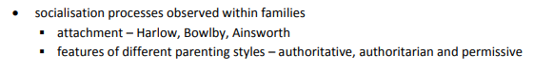

Wednesday, May 1, 2019

10:03 AM

**Socialization**

* **process whereby we acquire beliefs, values and behaviors that are thought to be important and appropriate to function effectively as a member of society.**
* **Agents of socialization affect our socialization and include families, schools, mass media, religious institutions and clubs.**

**Attachment**

* **Strong, close emotional bond between an infant and caregiver**
* **Does not necessarily have to be reciprocal**
* **Samtrock (2008) mutual love is crucial between an infant and its caregiver in the early years as it helps them to form relationships later on in life**
* **Privation is when attachment never occurs, which is generally detrimental to the infant**
* **Mcllveen & Gross (?) privation can cause permanent emotional damage, also found that attachment interruption can have poor outcomes (similarly to Harlow's "pit of despair")**

**HARLOW (1958)** - studied the role of feeding in infant-mother attachment using 8 monkeys that were separated from their mother at birth

* Monkeys were taken from their mothers and kept in cages with two 'surrogate' mothers, one with an exposed wire body and the other covered in terry cloth
* Monkeys were split into two groups, half with the wire mother providing the feeding and the other half with the cloth mother providing feeding
* Theoretically if an infant's attachment to its mother was based primarily on feeding, the infant monkeys should have preferred and become attached to their respective 'surrogate mothers'
* It was found that in **all** cases the monkeys preferred to be with the cloth mother, even if the wire mother was the one feeding it
* To see what the monkeys reaction would be to being scared (stressed) a mechanical contraption fittingly named (the mechanical abomination) was placed in the cage to scared the monkeys
* The scared monkeys would **always** seek comfort from the cloth mother, by rubbing its body against it
* **Harlow concluded that 'contact comfort' was provided by the softness of the cloth mother and was more important than feeding in the formation of an infants attachment to the mother, this was later concluded to be due to the infant feeling safe and protected whilst in the contact of another.**
* **Generalized his findings to suggest it was likely a crucial factor in human infant-parent attachment**

Harlow also trialed keeping some monkeys in partial and total isolation in bare wire cages that still allowed for them to see, smell, and hear other monkeys, but provided no opportunity for physical contact

* Partial isolation resulted in various anomalies such as blank staring, repetitive circling in the cage and self-mutilation
* Total isolation produced monkey that were severely disturbed
* *"when initially removed from total isolation, they usually go into a state of emotional shock, characterized by autistic self-clutching and rocking. One of six monkeys isolated for 3 months refused to eat after release and shortly died after (emotional anorexia)*
* *The effects of 6 months of total isolation were so devastating and debilitating that it was assumed that 12 months couldn't get any worse, which was false. 12+ months in total isolation almost obliterated the monkeys socially"*

**Pit of Despair**

* Baby monkeys were left alone in total darkness for up to one year from birth, or repetitively separated from their peers and isolated in the chamber
* These procedures quickly produced severely psychologically disturbed monkeys, which served as a model for human depression.

**Strengths**

* **Gives us a close representation of human behavior by using monkeys as opposed to humans**
* **These monkeys were orphaned so had no concept of a 'real' mother**

**Weaknesses**

* **Experiments were highly unethical and caused severe emotional trauma to the monkeys - sometime fatal**
* **Not a completely accurate representation of human attachment as there are more complex factors that can influence human infant attachment**

**Bowlby (?)** - babies attach for **survival - a biological need**

**Monotropy -** strong attachment to **one** primary caregiver, first attachment to form

**Critical Period -** time when attachment **must** form or will not form at all. 0-3 years old, although it is marginally better if in the first year attachment is achieved, if this is not formed it leads to a multitude of issues in later life.

**Deprivation -** loss of attachment - through parental death or illness, hospitalization etc, can lead to needy children who struggle in society (school etc)

**Privation -** lack of attachment, institutionalized children or neglected from birth (Genie)

John Bowlby began researching attachment theory by observing children in institutions

* Found that some institutions provided better levels of care and nurturing than others
* Basic need were catered for but lacked human contact
* He took a largely biological/evolutionary perspective

Infants formed attachments to their parents/mother in order to protect themselves from predators and grow to have their own offspring…for a greater chance of survival

Precise permanent learning occurring early in infants life where they form a bond with their mother

* Bowlby thought that mothers had a biological need to be close to their child (leading them to be responsive to things like crying etc)
* These behaviors are done by infants in order to attract their mothers attention - known as signal behaviors
* It is mutually innate In bother infant and parent-reciprocal bonding
* The failure to bond could lead to the child not being able to form relationships later in life
* **Monotropy**

**Attachment as a close bond with only one figure**

**The primary bond is more important that any other attachment**

**Monotropy is the conceptual attachment formed by a close and important bond with a single primary caregiver. Bowlby proposed that if this monotropic bond did not occur then negative consequences would occur. Monotropy is a part of the maternal deprivation hypothesis.**

* Reciprocal relationship

Child acts in a way to elicit a behavior from primary caregiver

Caregiver responds, eliciting behavior from the child

* Monotropic bonds help to maintain proximity between the parent and infant and also offers the infant the opportunity to develop skills and an understanding of how to attach and bond to others. Bowlby suggests that attachment takes place during the **critical period**
* It is suggested that if the child does not form an attachment during the critical period (first 2.5 years) they will not be able to anymore. If attachment is not developed during this period, then the child will suffer from irreversible developmental consequences like reduced intelligence, increased aggression etc.

**Maternal Deprivation - separation from/loss of mother and failure to develop attachment**

**Primary attachment with mother leads to the child forming an INTERNAL WORKING MODEL of relationships, ie the relationship with their mother acts as a template for all future relationships.**

* 3 main features of the internal working model include

1. A model of other being trustworthy
2. A model of the self being valuable
3. A model of the self as effective when interacting with others

**Bowlby claimed that there are 4 main stages in the development of attachment**

1. **Preattachment (birth - 3 months)** the infant responds to people, but does not discriminate between people, innate signals attract the caregiver which encourages the adults to stay close as the infant feels safer in the presence of adults.
2. **Preliminary attachment (3-12 months)** the infant will begin to respond to familiar people with smiles and will prefer to be with the primary caregiver over others, will express this preference by becoming upset or difficult to calm when not with the primary caregiver.
3. **Clear-cut attachment (12-18 months)**  infant is more mobile and can crawl or walk to be closer to the primary caregiver- they use the primary caregiver as a 'base', can display separation anxiety when separated - becomes upset when the primary caregiver leaves, if no concept of object permanence has developed separation anxiety is uncommon, level of distress in these situations is dependent on the supportiveness/sensitivity of the caregiver
4. **Formation of reciprocal relationship (18 -24+ months)** toddler is able to understand some factors that influence coming and going of caregiver - declining separation protests, child can negotiate with the caregiver - uses requests and persuasion to alter goals, as age increases, dependency on caregiver will be accessible/responsible in times of need

**Components of attachment -** Four key components to attachment

1. Safe haven - when the child feels threatened or afraid, he/she can return to the caregiver for comfort and soothing
2. Secure base - the caregiver provides a secure and dependable base for the child to explore the world
3. Proximity maintenance - the child strives to stay near the caregiver, thus keeping themselves safe
4. Separation anxiety/distress - when separated from the caregiver, the child will become upset and distressed.

**Strengths**

* **Lots of empirical support from Bowlby's own research and other theorists, Tronick et al (1992), Shaffer & Emerson (1964), Minnesota longitudinal study (2005)**

**Limitations**

* **Possibly too much of an emphasis on a singular attachment figure**
* **Attachment may be influenced by the infant's personality and not only the caregiving**

**Ainsworth (1978) - best known for her elaboration on Bowlby**

* **Developed the strange situation scenario where a child is observed playing for 20 minutes whilst caregivers and strangers enter and leave the room, recreating the flow of familiar and unfamiliar persons in the lives of moths children - the amount of exploration and the child's reaction to the departure and return of the caregiver are observed**
* A successful outcome is secure attachment and an unsuccessful outcome is anxious-ambivalent insecure attachment or anxious-avoidant insecure attachment

**Secure attachment (Type B)**

* Shows distress when separated from caregivers and are happy when their caregiver returns
* Seek comfort from caregivers when frightened or confronted by strangers
* Feel they can depend on caregiver to return or to provide support and safety
* Often have trusting, healthy relationships
* Tend to have good self-esteem and are comfortable sharing feeling with friends or partners

**Insecure avoidant/anxious attachment (Type A)**

* Usually become very distressed when a parent leaves but is not comforted by the return of the caregiver
* Can be both clingy and angry on caregivers return (inconsistent)
* Feel like they cannot depend on the caregiver to return or provide support and safety
* Often reluctant to form relationships with others
* Can become distraught and angry when relationships end
* This attachment style is considered relatively uncommon, affecting an estimated 7-15% of children
* Research suggests that this type of attachment is due to poor maternal availability, children cannot depend on their mother to be there.

**Insecure ambivalent/resistant attachment (Type C)**

* May avoid parents or caregivers
* Don’t seek much comfort or contact from parents
* Shows little or no preference between caregiver and stranger
* Doesn't explore much and seems disinterested
* Feels that their needs will not be met and doesn't view their caregiver as someone who can provide support and safety
* Tend to have low self-esteem and invest little emotion into social and romantic relationships
* Unable tor unwilling to share thoughts and feelings
* Research suggests that this attachment style might be the result of abusive or neglectful caregivers, children and punished for relying on their caregiver and learn to avoid seeking help in the future.

**Children who fail to form secure attachments early in life can have negative impacts on behavior in later childhood and throughout life. Children diagnosed with oppositional-defiant disorder (ODD), conduct disorder (CD) or PTSD frequently display attachment problems, possibly due to early abuse, neglect or trauma. Children who are adopted after the age of 6 months have an increased risk of developing attachment problems.**

**Strengths**

* Strictly controlled factors that helped to produce valid results

**Weaknesses**

* Conducted in artificial environments may have influenced child's response
* Only tests mother-child's response
* Only American participants

**Cultural differences**

* In individualistic cultures generally showed more avoidant types
* In collectivist cultures generally showed more anxious/ambivalent types
* Israel things
* The meaning of the types of attachment may be different in different culture (Gross et al 1995)

**Communication**

Communication

Tuesday, May 14, 2019

8:42 PM

Communication is fundamental to human social interaction. It involves the transmission of a message from one person to another. Humans are constantly communicating - intentionally or unintentionally - their thoughts, feelings, observations and hopes.

According to Vaughan & Hogg (1998), communication is social in three ways

* It involves inter-relationships among people
* It requires that people acquire a shared understanding of what particular sounds, sounds, words, signs and gestures mean
* It is the means whereby people influence others and are in turn influenced by them

Communication requires a speaker or sender of information/message, but communication is more complex than this, since a speaker can also be a listener and there can be multiple messages.

**Communication styles**

**Assertive -** in assertive communication you express your beliefs, feelings, opinions and thoughts in an open respectful manner that does not violate the right of others. Assertive communicators use actions and words to express their boundaries in a calm, confident manner.

**Aggressive -** in aggressive communication you do not hold any respect for others. It disregards anyone else's needs, feelings, opinions and ideas and sometimes this can compromise the safety of others as well. Aggressive communicators are identified by their demanding, manipulative, angry and self-promoting behavior. The body language of an aggressive person might be fist-clenching, crossed arms, scowls, or staring at someone.

**Passive -** Passive communicators are often silent since they lack respect for themselves, while not giving any importance to their own needs, feelings, opinions and wants. Passive communicators put their own needs after everyone else's, allowing for other to decide how things will turn out. Often, they have body language that might include covering their mouth, looking down, avoiding eye contact and crossed arms.

Bernstein, Labov, Tannen

Wednesday, May 1, 2019

10:03 AM

**Bernstein (1971)**

* Claimed that people from the working and middle classes in the United Kingdom used different kinds of language codes. Language codes are the types of language used that reflect particular social groups. Working classes are those people who work for wages in jobs such as manual labor or industry, the middle class of a social hierarchy is comprised of people who work for salaries as professionals and in the public service.
* Bernstein considered that people in the working class relied on preserving traditional roles and ways of interacting: they used a **restricted code**
* By contrast, people from the middle classes wanted to develop ideas in relation to their personal experiences, so in addition to using a restricted code, they also used an **elaborated code** in their interactions.

Restricted code

* Short and simple sentences are used, with much information conveyed non-verbally
* Much of the meaning only makes sense if the context is known
* Few descriptive words are used
* Commands are frequently used to gain compliance
* The 'here and now' is stressed
* Abstract ideas are rarely expressed

Elaborated code

* Complex, precise sentences are used
* The meaning is clear from the sentence alone
* More use is made of descriptive words
* Explanations are usually used to gain compliance
* Reference is made to events in the past or future
* Abstract ideas, future possibilities and so on are expressed easily and often

Bernstein considered that children in working-class families had a language deficit because they could only use the restricted code. He claimed that this limited their ability to benefit from education.

**Labov (1970)** used his work with children who spoke African American Vernacular English (AAVE) to challenge Bernstein. Labov considered that AAVE was just as complex and rule-governed as standard English and that is should be considered different, not deficient.

He said that there was nothing inherently more complex, for example in the standard English comment "he doesn't know anything" than in the AAVE comment "he don't know nothing". He was particularly concerned with teachers not accepting AAVE as it was considered useless.

**Different communities have different Vernaculars due to the way that they interact with each other, their communication is just as complex but it is seen as different due to it not conforming to generic English. Its not deficient it's different.**

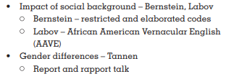

**Tannen (1990) - gender differences**

Men tend to use **report talk** - which is the type of talk used in public speaking and for information sharing. When telling jokes or stories they are comfortable with being centre stage. They use speech as a way of gaining and holding the attention of the audience and to negotiate and maintain status.

* Get more talking time and exchange information with little emotional connection
* Are more public with their speech
* Use language to negotiate status and avoid failure
* Talk in turn

Women tend to use **rapport talk** - which is the style of interaction that is based on establishing relationships and intimacy, developing understanding and negotiating differences. Tannen considered that women enjoyed private conversation more than men, and this requires shared experiences.

* Use speech to establish and maintain emotional connections
* Focus on personal and small talk 'chat'
* Use speech to build relationships and maintain intimacy
* Tend to talk over and above one another, overlapping and simultaneous talk

Chomsky & Bruner

Tuesday, May 14, 2019

2:24 PM

**Chomsky (1968) - Nativist theory of language**

* Language was something that developed naturally as everyone learned how to speak their own native language
* Language Acquisition Device (L.A.D)

Humans have a biological predisposition for language. The LAD is a 'black box' that allows us to understand the structures of language. Input is then required from the native language spoken around the child in order for it to generate sentences.

* Because language is so complex you can't just learn it as a child, therefore some aspects must be innately specified (innate hypothesis)
* Children are born with **universal grammar** - all grammatical information required to produce language
* Language development is innate due to:

Children master language skills faster than other abilities

Children do not simply copy language or learn all phrases, but uncover the rules and the create new unlimited phrases

Deep structures (universal grammar) is the same in all language - therefore is genetically determined

**Strengths:**

* This theory accounts for how children rapidly acquire language
* Argues that children could not acquire language rules in this space of time and his theory accounts for their abilities in this area
* Children all learn language at approximately the same rate irrespective of what language they speak
* Does not require a trigger for language acquisition to begin
* Correcting the child's structure shows no impact the child will still comprehend the language in the same way and continue to use it in the same way until further input has been gained
* Accounts for the ability to manipulate language effectively rather than simply learn phrases

**Weaknesses**

* Theory pays little attention to the social environment that the child develops within. With the exception of language spoken
* No evidence to support the existence of the LAD through a brain scan (LAD could be the development of the entire brain - Genie)
* Does not account for the influence of patterns in language that are discussed in the cognitive approach
* Universal grammar isn’t possible
* Grammar can take forever to learn which shouldn't happen if it is innate
* No neurological evidence for a biologically based LAD
* Example of feral child Genie

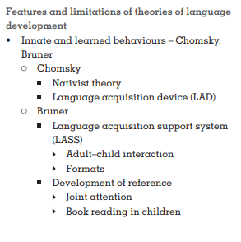

**Bruner (1983) - Constructivist Theory**

* Sees learning as an active process and emphasizes the interaction between the caregiver and the child
* Supports the concept of the LAD but argues that Chomsky's theory fails to take into account the role of the caregiver
* Language Acquisition Support System (L.A.S.S)

Children learn language through verbal interaction with caregiver, words develop meaning through routines (example - bath time)

* The LASS needs the LAD - child component (innate predisposition) and the interaction with other than allows for language to be acquired
* Language develops through interaction during routines. In order for this to be utilized the following must be in place:
* **Scaffolding - the provision of an instruction framework (supplied by the caregiver) for example pointing the words as the caregiver reads them to the child**
* **Format - an appropriate time/place for the learning to occur, this should be within the format of the standard routine ie, dinner time, bed time, bath time or through book reading**
* **Reference - the management and directing of attention, which should begin with**
* **Joint attention - mutual eye contact and may progress outwards to pointing and verbalizing**

**Strengths**

* Based on research the LASS was developed based on a longitudinal study of 2 boys, 3 girls over 24 month
* Takes into account social interaction as well as language input, therefor improving on Chomsky's theory
* **Interactionist theory** - environmental and biological factors

Yes - children have strong biological predispositions to learn language

Yes - social support and social context is necessary to learn language

* LASS, strategies employed by parents to facilitate the acquisition of language

**Strategies include, scaffolding, infant-directed speech, expansion and recast**

**Reference - how people manage/direct each other's attention through linguistic means**

**^used by mothers to establish the names of objects and other things**

**Weaknesses**

* Theory is reliant upon the existence of the LAD in order to explain aspects of language acquisition and therefore can be subject to some of the same criticisms as Chomsky
* No evidence to support the existence of the LAD through a brain scan (LAD could be the development of the entire brain - Genie)
* Theory pays little attention to the social environment that the child develops within. With the exception of language spoken

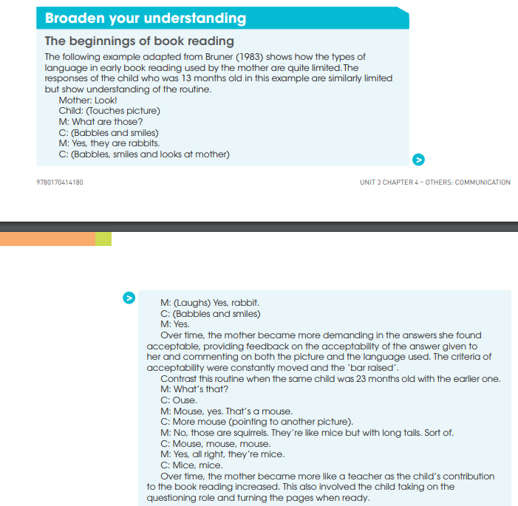

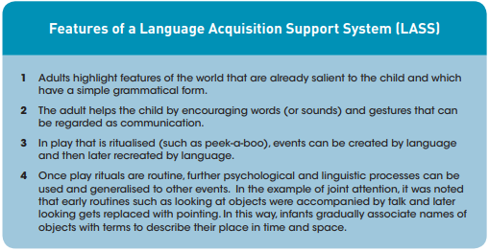

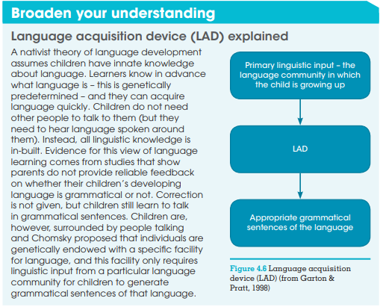

Persuasive Communication

Thursday, May 16, 2019

8:46 AM

6 Principles of Persuasion

1. Reciprocity
2. Scarcity
3. Authority
4. Consistency
5. Liking
6. Consensus

Reciprocity

People are more likely to say yes to people they owe

Mint example

**Be the first to give, and to be sure that what you give is personal and unexpected**

Scarcity

People want things more that are scarce

Think limited stock items or rare stuff etc

Authority

**People will follow credible knowledgeable experts**

Liking

People are more likely to say yes to people we like

We like:

1. People who are similar to us
2. People who compliment us
3. People who have the same goals as us

Consensus

People will look to the action and behaviors of others to influence their own

Consistency

**Looking for and asking for small initial commitments that can be made**

Voluntary, active and public commitments

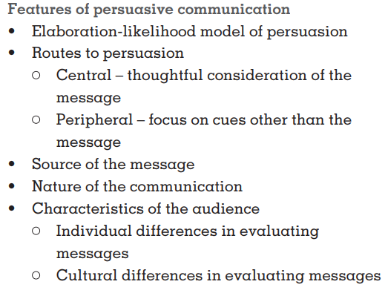

Persuasion definition:

Persuasion can be defined as the process by which attitude change is brought about.

The media has an important influence on attitude change, not only in the most obvious way of advertising but in the images and messages it conveys. We are talking about a whole range of attitudes from political ideologies to what to buy for dinner.

An attitude is a positive or negative reaction to a person, object, place or idea which involves feelings towards it.

More Hovland & Yale (1953)

* The process of attitude change

Hovland and his colleagues at Yale argued that people go through a series of four successive stages in attitude changes, all of which affect the degree of this change.

1. Attention - the amount of attention which is payed towards the messages influences the extent of the influence the message has on the person
2. The extent to which the message is understood
3. The amount of personal acceptance within the message
4. The retention of the message (remembering it)

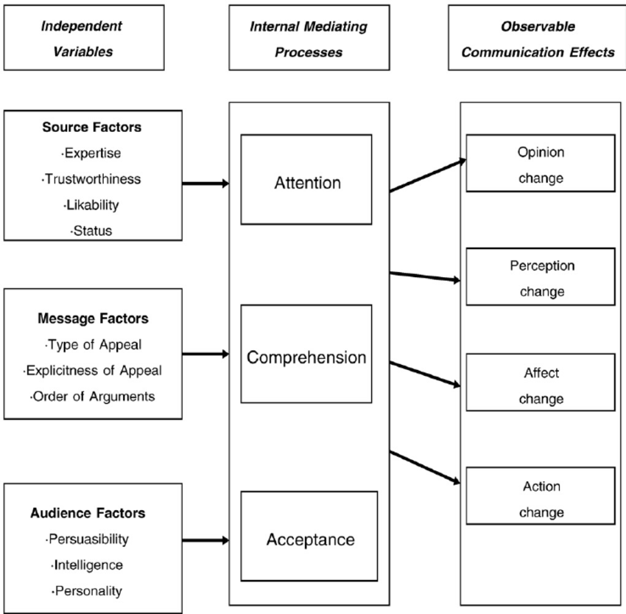

The Main Three Components

1. Source of the message

If the source of the message is somebody who is credible, professional or well-known in the field that is being presented the audience is highly likely to see them as a persuasive speaker, as they believe that they must be knowledgeable in the topic and should be trusted. For example if Gordon Ramsey was seen advocating the harmful affects of a popular cuisine, the large majority of the populas who see the advertisement would immediately be persuaded to some extent due to the person delivering the argument being someone well versed in the subject.

Hovland & Yale (1953)

* Experts (Hovland and Weiss 1951) people are more easily influenced by an expert or a journal than by a lay person or an ordinary magazine.
* Celebrities (Chaiken & Eagly 1983) people are more easily persuaded to buy things by a well-liked attractive celebrity, most likely due to wanted to be like them.
* Trustworthiness (Priester & Petty 1995) people are more easily persuaded by a trustworthy source than by someone who could be seen to be acting out of their own interest.

1. Nature of the communication

The nature of the communication is the content itself as well as the medium used for communication between the source and the audience. The medium used can be speaking, writing, SMS or social media, and the tone of the language can vary and can for example be formal/informal, accusatory/conciliatory or polite/rude.

Although there are times where we are 'won over' simply because of who is presenting the argument, there are also times when we carefully consider the argument being presented. When people understand the message and respond favorably to it, they are more likely to be persuaded. However, simply being exposed to a message does not necessarily mean that we understand it. Lots of persuasive information is lost due the misunderstanding of the message, so the rule of 'keep it simple' still remains immensely important.

Research has shown that advertisements that try to put people in good moods are more likely to be successful as when people are in jovial moods they tend to get complacent and think much more carelessly

Although the opposite works just as well, some adverts try to invoke a moderate sense of fear in the audience with health warnings or risks, if this type of persuasion is to be effective it must arouse enough fear to convince us to attend to the message, but not too much that we miss the message entirely because it is too emotional. High levels of fear can lead to complete avoidance of the message.

Hovland & Yale (1953)

* One sided or two sided: if you are trying to persuade someone to take a particular view, is it better to present the opposing argument s well as the one you want them to take, or just give a one-sided view? Hovland, Lumsdaine and Sheffield (1949) showed that a one-sided argument works well with people who are liable to agree with the argument and have not been exposed (or will go looking for) the counter argument. However, with people who are familiar with the opposing view, quite intelligent, or are well-informed, it is better to present both sides of the argument.
* Emotional or non-emotional: a threatening message can be effective but only if the recipient feels they can do something about it. A highly threatening message about, for example, the dangers of drugs or smoking, works well if the recipient have never used them or use them minimally, but not for addicts.

1. Characteristics of the audience

* Individual differences in evaluating messages

Individuals differ in how carefully they will evaluate a message, or argument. Research has shown that some people enjoy examining issues, checking for inconsistencies or weighing up the pros and cons in a debate. People like this are more likely to be persuaded by a strong argument that is well written and delivered, but remain completely un-moved by arguments which rely on the notoriety of the speaker and the nature of the communication to try and persuade as they argument itself is generally weak. People who don't think in this type of way, generally don't seem to think a lot about the inconsistencies or analyze the argument at all, and are more likely to be swayed by those with expertise, trustworthiness and a good medium for communication.

Hovland & Yale (1953)

Need for cognition (NC) people high in NC enjoy a challenge. They like working on difficult problems, searching for clues, analyzing situations. Cacioppo, Petty and Morris (1983): People high in NC are more easily persuaded by strong arguments, but less than those low in NC.

Sex: Eagly and Carli (1981) Both woman and men are more easily persuaded about topics they know little about and are not interested enough to care or learn about, than they are about topic they are well versed in.

Self-Esteem (Baumeister & Covington 1985) contrary to expectation, there is no difference in how easily people of low or high self-esteem are persuaded. The only difference is that people in high self-esteem don’t like to admit it.

* Cultural differences in evaluating messages

Min-Sun Kim and colleagues (1998) examined cultural differences in the way attempts at persuasion are evaluated. They based their study on known differences between individualistic and collectivistic cultures, with students from Korea, the US and Hawaii (which is a part of the US lol) The study found that those from collectivist cultures are more likely to consider indirect requests to persuade someone, whilst those from individualistic cultures considered direct requests as the best way to persuade someone.

Evaluation of the Hovland & Yale (1953) model

**It has provided a useful framework for further research** - this model represented the first systematic approach to understanding attitude change. Its emphasis on considering the message, communicator, and recipient has been very helpful in providing a template for future research.

**Many specific predictions of the model have been supported** - for example, that attitude change depends on the expertise and trustworthiness of the source.

**It has shown the importance of cognitive factors** - is has outlined the processes (eg attention,, comprehension) that recipients use when presented with a message

**It does not clearly indicate how the factors influence one another** - there are many factors to consider and, although the model covers some of the interactions, such as how personal knowledge relates to whether a one-sided or two-sided argument should be used, a lot of other interactions are not considered

**One prediction disproved** - There is no evidence that those low in self-esteem are more easily influenced than those high in self-esteem

**Processing through attention, comprehension, acceptance and retention successively is too simplistic** - the idea that these stages are followed in order is not necessarily the case, for example, once we start to think about the meaning of the message, we go back and pay some or all of it more attention, so we are not processing the information in a simple linear stage by stage manner.

**It does not take sufficient amount of internal factors** - The Hovland - Yale model concentrates on the external processes (the communication, communicator and recipient) but does not take sufficient account of the underlying internal factors (attention, comprehension and acceptance). These are only covered in more detail in the next model.

**Development**

Piaget

**Cognitive Development**

**Cognition:** the mental action or process of acquiring knowledge and understanding through thought, experience and the senses.

Friday, June 14, 2019

9:04 AM

Piaget Stages of Cognitive Development

|  |  |  |  |
| --- | --- | --- | --- |
| Age Range | Stage Name | Description | Developments |
| 0-2 | Sensorimotor | World is experienced through the senses and through actions | * 1. Object permanence - occurs half way through the stage; able to know objects don’t disappear just because they are out of sight; know object still exist.      * 1. Stranger anxiety. |
| 2-6 | Preoperational | Childhood thoughts that begin to represent objects with words but which lacks logical reasoning | * 1. Language development.      * 1. Pretend Play.      * 1. Egocentrism - inability to see a point of view apart from your own.      * 1. Theory of Mind - ability to understand someone else's mind set. |
| 7-11 | Concrete Operational | Childhood begins to think logically and forms ability to complete simple math operations. Logic is tied to things they can see…cannot hypothesize. Disregard illogical thinking patterns of egocentrism, animism and artificialism. | * 1. Conservation - ability to understand that matter does not increase or decrease because of a change in form. (Water in glass).      * 1. Reversibility - idea that order doesn't matter in addition. (2+3 is the same as 3+2). |
| 11+ | Formal Operational | Invokes the ability to think abstractly and hypothetically | * 1. Abstract logic - thinking about things like communism, algebra or hypothetical situations.      * 1. Ability for mature moral reasoning. |

Theoretical Criticisms

Ages:

* Much research has seemingly demonstrated that children possess many of the cognitive abilities that Piaget outlined at ages much earlier than expected.
* Often improving upon, or altering, the method of testing/assessing the child reveals their cognitive abilities better Wishart (object permanence) & Hughes.
* In addition piaget seemed to have over-estimated people's formal operational ability - some research suggested that only one third of the population can reach this stage.

Concepts:

* While Piaget's theory provides us with a detailed description of development, some have said that is does no really provide an explanation of it.
* Some of the concepts are quite vague, and the stages tend to overlap, which suggests that development is more of a continuous process rather than something done in stages
* By focusing on the child's mistakes, Piaget may have overlooked important abilities that children do possess, or may have wrongly deduced the reason for failure

Neglects:

* Piaget neglected many important cognitive factors that could have accounted for the individual differences in development that children may show, such as memory span, motivation, impulsiveness, practice, etc.
* Overall in many researchers view he severely underestimated the social influences on development. By concentrating on individual maturation and self construction of mental life.
* Piaget neglected: a) the role of society in facilitating and providing increased understanding. B) the child's understanding of social situations. C) the children's ability in and use of language at different ages

Methodological Criticisms

Inappropriate Tests:

* A frequent criticism is that Piaget's experiments were over-complicated an difficult to relate to.
* By simplifying the tasks and ensuring that they made what Donaldson has termed 'human sense'. Other researchers have found children who have demonstrated cognitive abilities they would not be expected to show.

Demand characteristics:

* Even in fairly uncomplicated tasks Piaget's experiments ignored the child's social understanding of the test, and may have led the child to give a socially desirable or expected answer rather than what the child really thought or understood.
* McGarrigle and Donaldson (1974) with their 'naughty teddy' experiment, and Rose & Blank (1974) with their question variation both found greater conservation rates in pre-operational children.

Overall Methods

* Piaget's use of the clinical interview method, informal experimentation, and small sample sizes, lacked scientific rigor.
* Although these methods had their advantages, the generalized conclusions drawn from them may have been somewhat biased.

Strengths

Theoretical Importance:

* Piaget's theory has received a lot of longitudinal cross-sectional support over many years, and while the theory has been subject to modification and criticism, many fundamental aspects of his theory are still accepted as valid contributions today
* Many psychologists have taken Piaget's ideas far more rigidly than they were originally intended. Piaget modified his theory to take into account certain criticisms and hoped that one day it could all be integrated with other theories that dealt with aspects of children's internal life that he had ignored.

Productivity:

* Piaget's ideas generated a huge amount of critical research which has vastly increased our understanding of cognitive development
* Bruner and more socially oriented theorists used Piaget's views as a spring board of sorts to develop their own and answer many questions raised by Piaget's research.

Applications:

* Piaget's views have had an important impact on educational practice - changing the way children are taught today and hopefully making education more effective and enjoyable.
* Piaget has also contributed to psychological theories of children's play and moral development.

**Donaldson**

Claimed that the three mountains task was unrealistic and claims that Hughes' experiment with the 'police doll' task was far better as it related more to the child's everyday experience. Found that 90% of children aged between 3-5 were able to hide the doll successfully.

Important Terms:

Schema - We build an understanding of our world ad develop our thinking skills through our interactions with our environment, which allows us to categorize what we see into schemas.

Assimilation - we interpret new experiences and information in terms of our current understanding (existing schemas) and integrate them into our existing understandings. For example a child who only has seen large dogs is still able to identify a dachshund as a dog.

Accommodation - If an existing schema needs adjusting because it is too broad, it is adjusted to incorporate more complex and specific information, which is called accommodation. For example is a child sees a cat but only has a schema for dogs being fluffy 4 legged animals it will call it a dog, when corrected they will adjust their schema to fit this new understanding, accommodating for the information.

Equilibrium - The child's state being in a state of balance and stability

Egocentrism - Children believe that they are the centre of everything and cannot choose to see things from other peoples perspective, a way of testing for this is the three mountains task.

Object Permanence - If the child cannot see an object they do not believe that it exists, this can be tested for by placing an object under a cover of sorts, if the child does not look for the object where they last saw it, they still do no have object permanence.

Conservation - The understanding that an object does not change its weight, mass, volume or area simply because it changes shape/form. (clay ball or liquid in glasses etc)

Reversibility - The idea that things can be the same although they may appear different, 3 + 2 is the same as 2 + 3 etc.

Abstract thinking - The child has the ability to hypothesize and understand complex situations such as what if scenarios, this can be tested by seeing if the child can understand what if scenarios.

Animism - the child believing that their toy/stuffed animal is real and can talk (pretend friends/pretend play)

Centration - The tendency to focus on one salient aspect of a situation and neglect other, possibly relevant aspects, often demonstrated in the pre-operational stage.

Symbolic thought - a majority advancement in the preschool years is the acquisition of symbolic thought, which is a type of thinking in which symbols or internal images are used to represent objects, people, and events that are not present (also comes under pretend play)

Kohlberg

**Moral Development**

Tuesday, June 18, 2019

1:52 PM

**Moral reasoning: the process in which individuals try to determine the difference between what is right or wrong by using logic.**

|  |  |
| --- | --- |
| Levels | Stages |
| Pre-conventional | Stage 1 - Punishment & Obedience  Heinz should not have stolen the drug because he will be put in prison and that makes him a bad person **OR** Heinz should steal the drug because it is only worth 200 dollars and he even offered to pay and wont steal anything else.  Stage 2 - Reward & Self-interest  Heinz should not steal the drug because prison is an awful place **OR** Heinz should steal the drug because he will be much happier if he saves his wife |
| Conventional | Stage 3 - Conformity & Good boy/nice girl  Heinz should not steal the drug as stealing is bad and he is not a criminal, and he already tried without breaking the law so you can’t blame him **OR** Heinz should steal the drug because his wife expects it and he wants to be a good husband to his wife.  Stage 4 - Law & Order  Heinz should not steal the drug as the law prohibits stealing making It illegal **OR** Heinz should steal the drug because he should take the punishment and pay the chemist, and actions have their own consequences. |
| Post-conventional | Stage 5 - Human rights  Heinz should not steal the drug because the scientist has the right to fair compensation and although his wife is sick it does not make his actions correct **OR** Heinz should steal the drug as everyone has a right to choose life regardless of the law  Stage 6 - Universal human ethics  Heinz should not steal the drug because others may need the drug just as badly and their lives are equally as significant **OR** Heinz should steal the drug because saving the life is a more fundamental value than the property rights if another person. |

Kohlberg used the Heinz dilemma to observe the **reasoning** behind each persons response, it wasn’t about the direct choice that they said Heinz should have made it was about how they justified it. So Kohlberg used the Heinz dilemma because it is open-ended and has no correct answer, it allows for people to say what they actually think without being influenced by anything which is what Kohlberg wanted. He then categorized the responses into the 6 stages that now form his theory.

Relationship between Piaget and Kohlberg:

Most children in specific periods of their lives shared multiple similarities between Kohlberg and Piaget's stage theories. The general relationship between them is:

Pre-operational --> Pre-conventional

Concrete operational --> Conventional

Formal operational --> Post-conventional

Although some people may never reach certain stages like Post convention.

Contributions:

Shaffer - outlined stages of attachment

Snarey - cross cultural universality of moral development

Colby - Longitudinal research on Kohlberg's stages

Limitations:

Shweder & Isawa - Cultural limitations - people who live in different societies or countries may have different morals based on how they are raised and the environment in which they grow up in.

Gillian - Gender bias

Kohlberg's study was conducted on all male subjects so Gillian decided to create her own approach which focusses more on Justice and Caring, so how more abstract moral principles like fairness equality and rights under the law, and also how a decision may affect the lives of others.

Lyons created a more "gender friendly" version of the Heinz dilemma called the porcupine and the moles (which has also been heavily criticized as unrealistic) that follows under Gillian's model.

Erikson

**Social Development**

Tuesday, June 18, 2019

1:52 PM

|  |  |  |  |  |  |
| --- | --- | --- | --- | --- | --- |
| Stage | Age | Crisis | Important Events | Outcome | Life stage 'virtue' |
| 1 | 0-1 | Trust vs Mistrust | Feeding | Children develop a sense of trust when caregivers provide reliability, care and affection. A lack of this will lead to mistrust in their caregiver. | Hope |
| 2 | 1-3 | Autonomy vs Shame and Doubt | Toilet Training | Children need to develop a sense of personal control over physical skills and a sense of independence. Success leads to feelings of autonomy, failure leads to feelings of shame and doubt. | Will |
| 3 | 3-5 | Initiative vs Guilt | Exploration | Children need to begin asserting control and power over the environment. Success in this stage leads to a sense of purpose. Children who try to exert too much power experience disapproval, resulting in a sense of guilt. | Purpose |
| 4 | 6-11 | Industriousness vs Inferiority | School | Children need to cope with new social and academic demands. Success leads to a sense of competence, whilst failure leads to feelings of inferiority. | Competence |
| 5 | 12-18 | Identity vs Role confusion | Social Relationships | Teens need to develop a sense of self and personal identity. Success leads to a ability to stay true to yourself, while failure leads to role confusion and a weak sense of self. | Fidelity |
| 6 | 18-35 | Intimacy vs Isolation | Relationships | Young adults need to form intimate, loving relationships with other people. Success leads to strong relationships, while failure results in loneliness and isolation. | Love |
| 7 | 35-55 | Generativity vs Stagnation | Work and Parenthood | Adults need to create or nurture things that will outlast them, often by having children or creating a positive change that benefits other people. Success in this stage leads to feelings of usefulness and accomplishment, whilst failure results in shallow involvement in the world. | Care |
| 8 | 55+ | Ego Integrity vs Despair | Reflection on Life | Older adults need to look back over life and feel a sense of fulfilment. Success at this stage leads to feelings of wisdom, while failure results in regret, bitterness and despair. | Wisdom |

Crisis' at their respective stages need to be responded to and solved or else the person will enter the next stage maladaptively which will cause them to struggle in latter stages of life. If a crisis is not solved it doesn't mean it will never be solved, just that it is later than usual and will impede progress towards the new crisis at hand.

If a person responds and solves their crisis then they enter the next stage adaptively and prepared for what is to come and will most likely be able to overcome the crisis' they will be facing in the future.

Stages can overlap and the age ranges may not apply to certain people as they may progress faster or slower. For example if children aged 14 are having intimate relationships then they are in an overlap between stage 5 and 6, but they are not maladapted or anything just progressing in a more unconventional way.

Stages 1-4 are very based and determined by others such as parents or teachers, whilst;

Stages 5-8 have more concern to do with the individual as they have more control over the environment, and they are directly responsible for the crisis resolution in each stage.

Limitations:

Sometimes in different cultures timing can be vastly different when being compared to that in the eight stages. For example some cultures have children marry as early as 12-13.

Erikson's theory is more applicable for boys than girls, as it was constructed when women held a lesser role in society and generally were not considered.

Erikson's work had a tendency to pay more attention to the earlier ages and stages, despite the so called claim that his eight stages are an entire life span theory, which can be questioned considering the broader nature in the latter stages.

Bradley & Marcia - generativity and stagnation study

Gething & Hatchard - life span development

**Personality**

Personality

Thursday, August 1, 2019

9:33 AM

Personality is defined as the characteristic ways in which a person thinks, feels and behaves. Personality makes people who they are. While we all have an understanding of what personality is, it is not a 'thing' that we can directly measure. Like intelligence, personality is a construct we infer from a persons behavior. Psychologists are interested in better understanding the nature of personality: what it is, whether it is stable or changes over time and how useful it is in predicting behavior.

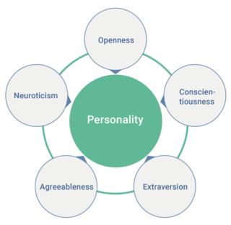

Trait theory

Tuesday, July 30, 2019

1:59 PM

Personality traits describe the stable forms of behavior that people display in any and every situation. Traits are inferred from behavior and it is expected that people behave in similar ways to different circumstances. Traits can be used to predict future behavior. The whole trait approach to personality moves beyond the early type approaches, like that of Sheldon, who saw personality as being related to physical appearances and body types.

It categorizes people by using more than one dimension. In this way, researches are in a much better position to capture people's individuality in full.

McCrae & Costa (1999):

Trait theories largely differ from each other on the number of dimensions that are considered to be important. Eysenck, considered that there were three main dimensions of personality: extroversion, neuroticism and psychoticism. McCrae and Costa, considered that there were in fact five dimensions to personality: extroversion, neuroticism, openness to experience, agreeableness and conscientiousness.

Extroversion: being related to the sociability of the individual and how easy found it to be assertive and emotionally expressive.

Neuroticism: related to how inward looking the person is and whether emotions are stable or not.

Openness: related to whether the individual enjoys new experiences and challenges, meeting new people and trying new activities.

Agreeableness: describes how good natured, cooperative and trusting the individual is.

Conscientiousness: related to the level of organization, dependability and preparedness to work hard.

*Xpand on all*

These five traits are known as the 'Big Five'

These traits are trying to describe and explain possible combinations of characteristics and how they predict behavior

Jia, Jia & Karau 2013 - conscientiousness and neuroticism both correlated negatively with cyberloafing, whilst Extroversion had a significantly positive relationship.

Nielson, Glaso & Einarsen (2017) found that being the recipiant of harassment was positively related to the factor of Neuroticism, but negatively related to the factors of extroversion, agreeableness and conscientiousness.

**Limitations of the trait theory - Stability**

* A claim of all trait theories is that personality traits are stable, enduring characteristics. If there is continuity in personality over time, each of us should be basically the same person in 5,10 or 15 years time. There is a considerable amount of research that suggests when adulthood is reached personality becomes largely stable, but at what age does this occur.
* Pullman et al (2006) conducted longitudinal research over a two-year period with Estonian adolescents ranging in age from 12-18 to look at several aspects
* Mean level consistency: are there changes in mean scored on each of the traits for each age group over time
* Individual continuity: do the personality traits of individual participants remain stable over time
* Rank-order stability: Does a person who scores high or low on a particular trait compared with his/her peers remain high/low relative to their peers, even if the whole group change
* They basically found that only a small amount of change occurs between these ages and that personality according to traits remains very stable
* Although the question remains as to whether we express our personality consistently across situations. (Mischel & Bandura)

Trait dimension 
Openness to experience 
Conscientiousness 
Extroversion 
Agreeableness 
Neuroticism 
End points of the dimension (low to high) 
Down-to-earth—imaginative 
Uncreative—creative 
Conventional—original 
Unadventurous—daring 
Negligent—conscientious 
Lazy—hardworking 
Disorganised—well-organised 
Late—punctual 
Loner—joiner 
Quiet—talkative 
Passive—active 
Reserved—affectionate 
Suspicious—trusting 
Critical—lenient 
Ruthless—soft-hearted 
Irritable—good-natured 
Calm—anxious 
Secure—insecure 
Unemotional—emotional 
Hardy—vulnerable 

Humanistic theory

Maslow's hierarchy of needs

Wednesday, June 26, 2019

10:42 AM

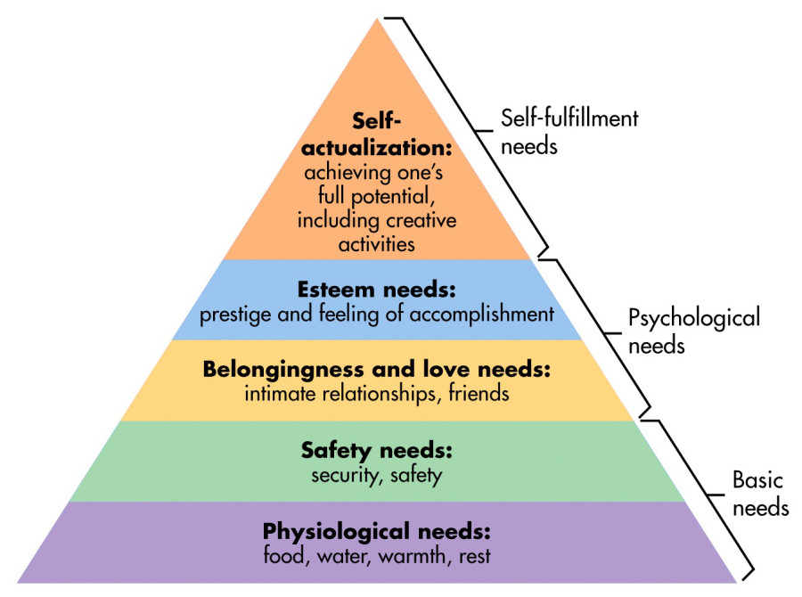

The tow main features of humanistic theories

1. All people are born good
2. Over the course of our lives we strive to reach our full potential (self-actualization)

Maslow

The humanistic approach in psychology developed as a rebellion against what some psychologists saw as the limitations of the behaviorist and psychodynamic theories of personality. The humanistic approach is thus often called the 'third force' in psychology after psychoanalysis and behaviorism (Maslow 1968). He aimed to provide an understanding of the factors underlying peoples characteristic ways of thinking, feeling and behaving. Maslow proposed the hierarchy of needs, starting with:

**Physiological needs (Basic needs)**

* Need for food, water, warmth, shelter and sleep

**Safety needs (Basic needs)**

* Sense of security and safety

**Belongingness and love needs (psychological needs)**

* Intimate relationships, friends a general sense of feeling like they belong

**Esteem needs (psychological needs)**

* Prestige and having a feeling of accomplishment so you can feel good about yourself and who you are

**Self-actualization (Self-fulfilment needs)**

* Achieving ones full potential including creative activities

He considered that individuals must satisfy their most basic needs at least partially before they are able to address the higher level needs.

Maslow studied self-actualizers: men and women who had made great use of their potential. He initially studied eminent historical figures including Albert Einstein, Abraham Lincoln and Eleanor Roosevelt. He developed a list of personal characteristics of self-actualizers

* Being idealistic and being involved in and working for a cause external to themselves
* Devoting their lives to the search for 'being values' (a reason to exist)
* Ultimate values such as truth, honesty and goodness

Maslow also identified certain behaviors leading towards self actualization:

1. Experience life vividly with full concentration and absorption
2. When faced with decisions, make the growth choice, not the fear choice
3. Listen to the 'impulse voices' rather than the voices of authority or tradition and let the self emerge
4. Take responsibility for decisions and actions and be honest rather than posing or playing games
5. Dare to listen to yourself and express your opinion even if it is different, non-conformist and unpopular
6. Work to do well at the things that you want to do and be as good as you can be
7. Set up conditions so that peak experiences are likely to occur
8. Be honest with yourself about your strengths and weaknesses: identify your defenses and give them up

Rogers

Rogers shared much of Maslow's thinking. He believed that people are born good and with the potential for enormous growth, like the seed of a large tree. Important people in our lives help us to grow by providing genuineness, acceptance and empathy, which are like sun, water and nutrients for a tree - necessary conditions for growth. A person who is genuine is honest and open with us, and does not put on a front. An accepting person who is genuine is honest and open with us, and does not put on a front. An accepting person is prepared to take us as we are, with all of our shortcomings; we do not have to change or improve to be valued or accepted. Rogers called this type of acceptance unconditional positive regard. A person shows us empathy, when they try to see the world from our perspective and understand how we feel. Rogers considered that we needed to experience these conditions from significant people in our lives: parents, teachers or mentors, in order to feel free to make any changes we want to make in ourselves - to grow and to self-actualize.

Central to Roger's theory is the concept of self or personal identity. If we are able to have a well-adjusted personality, there needs to be a good match between our ideal self, the person we would like to be, our self-image (the person we think we are) and our true self (the person we truly are). If we value things like kindness and compassion and think of ourselves as somebody who is kind and compassionate, we also need to act with kindness and compassion.

Roger's acknowledges that we are never all we want to be, he considered that the greater the gap between our ideal self, self-image and behavior, the more likely we are to feel stressed or anxious.

Scott & O'hara (1993) supported this belief by studying students whose ideal and self-images were discrepant, and found that these students were much more depressed and anxious than those with a solid self-image and ideal self.

Humanistic theories consider that personality cannot be measured using rating scaled, tests or inventories of the type looked at in trait theories. However, they do use a self-report method known as Q-sort. This consists of stack of cards on which are printed statements such as ' I try hard to please others', 'if I put my mind to it, I could do anything', 'success is important to me'. Rogers used these cards when working with clients in his clinic to look at the match between the ideal-self and the self-image. He would ask the client to arrange the cards twice (once for each) and considered that a person with a well-adjusted personality would arrange the cards in a similar order.

**Limitations of humanistic theories**

* The ideas of humanistic psychologists have had a big impact in areas ranging from counselling through to education and child-rearing. However, they have not been without criticisms
* One major concern has been with the vagueness of some of the concepts - such as self-actualization.
* Maslow's description of the characteristics of a self-actualized person are based of his heroes and are simply a list of his values
* The values that make somebody self-actualized are completely subjective, others may see different qualities as what makes somebody self-actualized completely changing the meaning.
* The theory is over optimistic and fails to consider human capacity for evil. We need to acknowledge both good and evil in this world if we are to be realistic. Rogers replied to this criticism by saying that he had never know an individual who, when provided with the conditions for growth had opted for the path of cruelness and destruction, which is not a great answer….

Social Cognitive theory

Tuesday, July 30, 2019

1:59 PM

Bandura (Social Learning Theory)

* Social cognitive theory stems from social learning theory (under the umbrella of behaviorism)

Behaviorism (Watson) supports a direct and unidirectional pathway between stimulus and response, representing human behavior as a simple reaction to external stimuli.

Social cognitive theory - people learn by watching others

* It explains personality in terms of how a person thinks about and responds to one's social environment.
* Behavior isn't determined by personality alone, their context e.g home, work, school also plays a role.

**People do not learn new behaviors solely by trying them and either succeeding or failing, but rather, the survival of humanity is dependent upon the replication of the actions of others.**

Social cognitive theory focusses on how we interact with our environment.

**Reciprocal Determinism:** the interacting influences between personality and environmental factors.

This is the central concept of SCT. This refers to the dynamic and reciprocal interaction of person (individual with a set of learned experiences), environment (external social context), and behavior (responses to stimuli to achieve goals).

**Self efficacy:** is the degree to which you are sure of your own ability and capability to manage and to be effective in meeting the demands of particular situations. We can acquire a strong sense of self-efficiency by mastering new skills and meeting challenges in specific situations. It develops in early childhood as we learn and master new skills, like walking, writing and riding a bicycle, and evolves throughout our lifespan as we meet and conquer new experiences. People can fail at tasks or activities for which they have the necessary skills because they believe that they cannot do them. Self-doubt and imagining dire consequences can impede or prevent successful achievements.

How we regard ourselves and our abilities varies depending on the situations or tasks that we face

**When we succeed at mastering a task ===> Our self-efficiency is enhanced**

**When we fail to manage or deal with a situation or task ===> Our self efficiency is undermined**

Bandura described human behavior as being the result of the interaction between behaviors, cognitive factors and environmental factors which he called reciprocal determinism.

Albert Bandura argued that when people see someone else rewarded for behavior, they tend to behave the same way to attain a reward. People are also more likely to imitate those with whom they identify.

Learning is shaped by factors in the environment especially reinforcements that students are exposed to, but also their thoughts and belief about themselves influence their behavior.

Cogn itive Factors 
Behavioural F actors 
mental Factors 

The Social Cognitive Perspective

1. Different people choose different environments.

The TV you watch, the friends you hang with, music you listen to were all chosen by you (your disposition). But after you choose the environment, it also shapes you.

1. Our personalities help create situations to which we react.

If I expect someone to be angry with me, I may give that person the cold shoulder, creating the very behavior I expect.

Personal control

* Our sense of controlling our environment rather than the environment controlling us

External locus of control

* The perception that chance or outside forces beyond one's personal control determine one's fate

Internal locus of control

* The perception that one controls one's own fate.

Limitations of Social Cognitive Theory

* The theory assumes that changes in the environment will automatically lead to changes within the person, when this may not be true.
* The theory is loosely organized, based solely on the dynamic interplay between people, behavior and environment. It is unclear the extent to which each of these factors into actual behavior and if one is more influential than another.
* The theory heavily focusses on the processes of learning and in doing so disregards biological and hormonal predispositions that may influence behaviors, regardless of past experience and expectations.
* The theory does not focus on emotion or motivation, other than through reference to past experience. There is minimal attention on these factors.
* The theory can be broad-reaching, so can be difficult to operationalize.

Mischel

Challenged fundamental assumptions about personality: specifically those held by trait perspective - consistency of traits across time and situation.

In 1968 he started the "situation vs personality" or "trait vs state" debate.

The central question: Situation or internal traits - which is more important in determining behavior.

Mischel's review of past research found that the correlation between a persons behavior and their "personality traits" was relatively weak: what he termed the 'personality co-efficient'

Maintains his viewpoint that traits aren't good at predicting a persons behavior

Examples:

* Someone who is typically extraverted is shy and reserved in an new environment amongst strangers
* A person who is usually arrogant will change their behavior if they sit next to someone they like, in order for them to like their behavior, the behavior changes based on the situation.

A key concept he presents is behavior specificity

* An individuals behavior is determined by the specific situation they find themselves in. If there are similarities in behavior across situations or times, its because similar or consequences are likely to be similar
* Therefore from Mischel's perspective, our behavior is more determined by the situation/environment that we find ourselves in rather than traits

Behavior is also influenced by our cognitions or **'person variables'**

Person variables' define how you react/ your behavior in situations and are based on prior experiences. Some of these variables are:

**Competencies -** what am I capable of doing - intellect and social skills

* You may be good at maths/science and act in specific manner in this class; you may be poor in english/humanities and therefore will approach them in a different manner (behave differently)

**Expectancies -** what is the outcome of this situation; what will happen in someone acts in a particular way

* Someone who is not rude to their friends/partners in public as they want to avoid disapproval from a larger social circle (judged by society) vs the same person who is rude/degrading to their partners/friends in private as they don't face the same social judgement.

**Values/goals -**  the desirability of the outcome of the situation; what really matters to you

* Working really hard in year 12 as getting a good ATAR matters to you vs putting in minimal effort into school during the previous years as school wasn't important.

**Encoding strategies -** how we process/perceive a situation

* One kid may find view a test a threatening whilst another won't

**Self-regulatory systems and plans -** how we see ourselves and react based on that(sort of like self-efficiency from Bandura)

* Behavior depends on intrinsic reinforcement or punishment, based on our own performance standards. Future goals are made and plans are then compatible with these goals. We are teleological and purposeful in our behaviors.

Delayed gratification

* Longitudinal research began in the 1960's (Stanford Marshmallow experiment - 4 year olds)
* Offered small immediate reward vs a larger delayed reward-needed to wait 15 minutes
* Follow up research found better life outcomes (better grades, healthier, greater professional success, and better at staying in relationships for those who waited for the delayed reward.

**Contributions of the social cognitive approach**

* Is well-grounded in psychological research and its concepts have been empirically tested
* Wide applicability in a range of areas such as education
* Takes into account the social setting of the individual

**Criticisms of the social cognitive approach**

* Critics argue that it ignores unconscious influences on behavior
* Doesn't explain how personality changes over time and as people develop
* Critics argue that it is not a unified theory, no connection between observational learning and self-efficacy

 Xtra

Personality - the characteristic ways in which an individual thinks, feels and behaves.

Tuesday, July 30, 2019

1:59 PM

Trait - personality traits are inherited through genetics

**McCrae & Costa**

Openness - enjoyment in new activities, meeting new people and trying new things

**High**

* **Imaginative**
* **Creative**
* **Daring**
* **Original**

**Low**

* **Down to earth**
* **Uncreative**
* **Conventional**
* **Unadventurous**

Conscientiousness - level of organization, dependability and willingness to work

**High**

* **Conscientious**
* **Hard-,hutxd,k8**
* **Well-organized**
* **Punctual**

**Low**

* **Negligent**
* **Lazy**
* **Disorganized**
* **Late**

Extraversion - general sociability of the individual

**High**

* **Joiner**
* **Talkative**
* **Active**
* **Affectionate**

**Low**

* **Loner**
* **Quiet**
* **Passive**
* **Reserved**

Agreeableness - good natured, cooperative and trusting

**High**

* **Trusted**
* **Lenient**
* **Soft-hearted**
* **Good-natured**

**Low**

* **Suspicious**
* **Critical**
* **Ruthless**
* **Irritable**

Neuroticism - how inward looking a person is and how stable their emotions are

**High**

* **Anxious**
* **Insecure**
* **Emotional**
* **Vulnerable**

**Low**

* **Calm**
* **Secure**
* **Unemotional**
* **Hardy**

**Contributions**

* Suggests that personality is stable due to it's genetic nature
* Looks at people through a number of different dimensions

**Limitations**

* **Different trait theories have a different number or traits that they decide to measure people based on, so no universal set of traits exist which places a large amount of distrust in the validity of trait theory.**

Humanistic - our personality develops based on what environment we are given to grow in

Two main ideas

1. All people are born good
2. People strive towards achieving their true potential over the course of their life

**Maslow** - Hierarchy of needs

1. Self-actualization - achieving one's true potential
2. Esteem needs - feeling of accomplishment
3. Belonging needs - sense of belonging and fitting in
4. Safety needs - safety and security (comfort)
5. Physiological needs - food, water, shelter, warmth, rest/sleep

**Biggest criticism**

**Rogers**

* Rogers believed that people were born good and that their personality is formed through them closing the gap (finding congruency) between their real self and ideal self.
* His definition of **self actualization** is when the true self is congruent (the same) as the ideal self.
* Real self - who we actually are
* Ideal self - who we want to become in the future
* Self-image - who we think we are

**Factors necessary for self actualization that come from relationships with others (early childhood)**

* **Genuineness**
* **Openness**
* **Empathy**
* **Unconditional positive regard -** we are accepted as who we are regardless
* **Acceptance**
* **Self-disclosure**
* **These help develop feelings of self-worth in early childhood, people who are able to self-actualize are more likely to have received unconditional positive regard**

**Contributions**

* **Used in counselling and psychotherapy (Q-sort)**
* **Takes into account our environment/upbringing/social impact**

**Limitations**

* Theory discounts the idea of human capability for evil and is overly optimistic in presuming how people will grow.
* Lack of scientific/empirical evidence (Rogers)
* Does not consider the role of biological influences on personality

Social Cognitive

**Bandura - social cognitive**

* **People learn from observing others, and replicate their actions if the outcome is desirable for the individual, for example, if someone saw someone getting praise for helping out an elderly person, the person would then help out other elderly people in hope of receiving that same praise.**
* **Reciprocal Determinism** - the way in which the cognitive aspects, behavioral aspects and situational/environmental aspects all influence each other, to form our personality at that time.

**Self-efficacy**

* The degree to which you are sure of your own ability and capability to manage and be effective in meeting demands in certain situations
* We can acquire a strong sense of efficacy by mastering skills, whilst constant failure will provide us with a very weak efficacy

**Mischel**

**Cognitive aspect**

* **People's behavior is influenced by the way they perceive and react to the situation that they are in, they choose their behaviors based on what out come that they think they behavior is going to have, rather than just acting how they normally would.**
* **Usually the behavior chosen is the one with the most desirable outcome for the individual**

**Person Variables -** define how you react to certain situations base on your prior experiences

**Competencies -** what you are capable of doing - intellectually and socially

* Someone who is good at Math's but bad at English is going to have a different approach to studying the two subjects

**Expectancies -** what is the outcome, what will happen if someone acts in a certain way

* Someone who is polite when out in public, but rude and abusive in private due to not wanting to be judged by society

**Values/Goals -** the desirable outcome of the situation, what you really want

* Working really hard in the last year of school because it is important vs not working hard at all prior due to it not mattering at all

**Encoding Strategies -** how we process/perceive a situation

* One person may find the idea of a test threatening another may find it as a challenge or as something to enjoy, or just not threatening

**Self-regulation -** how we see ourselves and react based on that

* Delayed gratification, behavior depends on intrinsic reinforcement or punishment, based on our own performance standards. Future goals are then made and plans are then compatible with these goals

**Contributions**

* **Integrated both trait and social cognitive approaches to personality**
* **Considered characteristics of a situation that might explain apparent inconsistencies in personality in different situations**
* **Explains the impact of beliefs on how a person acts in a situation**
* **Well grounded and empirically sound**
* **Wide rang of application such as in education**

**Limitations**

* **Ignores the unconscious influences on behavior**
* **Doesn't explain how personality changes over time as people develop**
* **Not a unified theory as no correlation exists between observation learning and self-efficacy**
* **Theory assumes that a change in the environment will automatically lead to a change within the person, whilst this is not necessarily true**
* **Theory is loosely organized and is centered around the idea that the relationship between the cognitive factors, behavioral factors and situation/environmental factors, but doesn’t explain if one if influencing more or the extent to which they have any influence to**
* **Disregards biological and hormonal predispositions**
* **Minimal attention to emotions and motivations**
* **The theory can be broad reaching so it can be hard to operationalize**

**Social**

Phillip Zimbardo*

Monday, September 16, 2019

8:45 PM

Obedience

Phillip Zimbardo and his colleagues conducted a study in 1973 to determine the effects of being either a prisoner or a guard. In the study, they recruited 70 young male university students through a newspaper advertisement, which sought men who were prepared to participant in a prison experiment for 2 weeks. From this group they selected 24 who were judged to be healthy, average young men with no psychological problems. Half of these were randomly assigned to the role of the prisoner and half to the role of the guard.

The prison was set up in the basement of the Stanford University psychology building, complete with cells, security doors and drab surroundings. Guards were issued uniforms, dark glasses, whistles, handcuffs and truncheons and were instructed to enforce the rules.

Prisoners were fake arrested by the police, blindfolded and transported to Stanford University where they were stripped, sprayed down and issued with smocks with numbers on them and made to share a small cell with two other inmates. In the days that followed, the guards developed rules to keep the prisoners in their place, and after suppressing an attempted rebellion, they became increasingly brutal in their treatment of the prisoners, humiliating them and subjecting their ringleaders to solitary confinement. The prisoners became dejected and dehumanized. Four prisoners had to be released over the first 4 days of the study as a result of severe negative reactions - crying, hysteria, rage and, in one instance a severe body rash. After six days the experiment was halted. The assigned roles given to the participants had become reality for them. Zimbardo was even concerned that he has becoming the prison superintendent and was becoming more concerned for the security of his 'prison' than for the study participants.

Zimbardo's study made him realize that social roles influence behavior in more complex ways than he had ever realized. The behavior of guards and prisoners was not simply a function of prisoners being criminals - as in this instance they were not - but the social environment of the prison and the roles of the participants influenced the way both the guards and prisoners behaved. Zimbardo's study received renewed publicity in 2003-2004 because of its relevance to the behavior of US guards at Abu Ghraib during the US military campaign in Iraq.

In any experiment with an emphasis on group influence on the individual their will always be some individuals who resist group influence. A committed individual or two who hold a minority view can in some instances, eventually sway majorities. Some influential people who are like this are: Mahatma Gandhi, Nelson Mandela and Martin Luther King etc.

A 
B 
C 
Figure 7.3 Cards similar to those used in Asch's visual judgement task. The card 
on the left has the reference line cmd the one on the right shows the three 
comparison lines. Solomon Asch*

Monday, September 16, 2019

8:45 PM

Conformity - changing our behavior in response to social/group pressures.

While our behavior may become more extreme when we are with like-minded people (Group polarization) it can change completely when we are with a group who see the world differently from us. Changing behavior in response to group pressure is known as conformity. This process was first studied experimentally in a classic study reported by Solomon Asch in 1955.

**Solomon Asch:**

Asch's experiment was set up as a simple visual judgement task. In groups of 8-10 participants seated around a table were shown two cards. On one, there was a set of three lines of different lengths. On the other, there was a single line. One by one the participants were asked which of the three lines was the same length as the single standard line. However unbeknownst to the real participant the others in the groups were all confederates of the experimenter. There were 18 comparison trials. For the first few trials, everyone agreed about which line was the same length as the standard, giving the obviously correct answer. But in 12 of the 18 trials the confederates all agreed on an answer that was incorrect, sometimes quite obviously. So the question was, what would the real participant do, give an answer in agreement with the group or follow their own instincts/senses?

Asch found that 75% of the participants agreed with the confederates on at least one of the trials and 50% echoed the confederates on 6 or more trials. Only 25% of people stuck with their own judgement the entire time.

Very few people like standing out and looking different from those around them. When we conform to group standards in order to be a part of the group and to be accepted by the group, we are experiencing **normative social influence.**

**Normative social influence** is the influence of other people that leads us to conform in order to be liked/accepted by them. Normative social influence can be seen heavily in friendship groups as they exert a strong influence on the way that we dress, speak and behave. Breaking social norms can lead to disapproval or even exclusion from the group. Social norms refer to the unwritten rules that govern social behavior.

We can also often conform when we are in strange situations that are new to us. We take our cues on how to behave from watching the people around us. This is known as **informational social influence.**

Later studies conducted by Asch and other psychologists investigated influence to the extent to which we are likely to conform to group pressure. **Group size** has been found to contribute as conformity increases with group size up to 4 then it stagnates. Of greater importance is the degree of unanimity. When others in the group are unanimous (agreed completely) it is difficult to stand out. However Asch found that if one other confederate was to also stand out it would help the participant voice their own opinion and are les likely to be influenced by social pressures.

**Bond & Smith (1996)** compared the data from 133 Asch-type studies carried out in 17 countries, they found evidence for cultural differences in conformity. The highest levels of conformity were found in collectivistic cultures, whilst lower levels of conformity were found in individualistic cultures. Achieving group goals is highly valued in collectivistic cultures, whereas being independent and achieving personal goals is valued more in individualistic cultures, so these findings are understandable.

Social Facilitation and Inhibition

Monday, August 19, 2019

1:54 PM

Impact of the presence of others on individual behavior - Social Facilitation and Inhibition

**Social Facilitation**

**Yerkes & Dodson (1908)** - discovered many years ago, people generally perform best at moderate levels of arousal. Their performance drops off when they are not sufficiently aroused and when they are over-aroused. The optimal level of arousal for best performance varies depending on the type of task we undertake. With simple or well-learned tasks, we perform better with a relatively high level of arousal. For difficult or new tasks, we perform better at lower arousal levels

Social Facilitation can be defined as '**an improvement in performance produced by the mere presence of others.**" There are two types of social facilitation: co-action effects and audience effect.

Co-action **(Presence of co-actor/s):** As demonstrated in Triplett's study, is a phenomenon whereby increased task performance comes about by the mere presence of others doing the same task. The co-action effect is present in everyday life such as working quietly in a library. Chen (1937) found that worker ants will dig more than 3 times as much sand per ant when working (non-cooperatively) alongside other ants compared to working alone. Platt, Yaksh and Darby (1967) found the that animals will ear more of their food if there are others of their species present.

**Triplett (1898)** Researched on the speed records of cyclists, he noticed that racing against each other rather than against the clock alone increased the cyclists' speeds. He attempted to duplicate this under laboratory conditions using children and fishing reels. There were two conditions: the child alone and children in pairs but working alone. Their task was to wind in a given amount of fishing line and Triplett reports that many children worked faster in the presence of a partner doing the same task.

Social facilitation occurs not only in the presence of a co-actor but also in the presence of a passive spectator/audience. This is known as the **audience effect**, surprisingly.

**Dashiell (1935)** found that the presence of an audience facilitated subjects' multiplication performance by increasing the number of simple multiplications completed. **Travis (1925)** found that well-trained subjects were better at a psychomotor task in front of spectators.

However, **Pessin (1933)** found an opposite audience effect, namely that subjects needed fewer trials at learning a list of nonsense words when on their own than when in front of audience.

It seems that the extent of social facilitation/inhibition depends upon the nature of the interaction between the task and the performer. In some cases the presence of co-actors/audience improved the quality of performance (Dashiell 1935) but in other cases it impaired the quality (through increase in quantity of trials etc).

According to **Cottrell (1968),** it is not the presence of other people that is important for social facilitation to occur but the apprehension about being evaluated/judged by them. We know that approval and disapproval are often dependent on others' evaluations and so the presences of others triggers an acquired arousal drive based on evaluation anxiety.

**Zajonc** discovered the missing piece to the puzzle, as in 1956 we conducted studies to figure out why some people performed better in the presence of others whilst others' performances were hindered. His experiments can be simplified into two parts, where he studied people performing simple vs complex tasks in front of other people. The results showed that people performing simple tasks where they have had a lot of practice were able to perform much better (facilitation) whilst those who had to perform complex activities that they didn’t have much practice doing who struggled (inhibition).

**Activation theory**, Zajonc proposed that the presence of others heightens arousal and thus increases an organism's ability to perform habitual/well-learned tasks. On the contrary, heightened awareness acts as a flaw when completing unfamiliar/complex tasks.

Arousal level: the presence of others causing a heightened sense in our bodies (increased adrenaline) causing us to be able to perform better.

Good if simple and well-rehearsed in the action that they are doing (facilitation), bad if the task is complex and unfamiliar (inhibition).

**Social Inhibition**

Later research done by **Triplett** showed that the presence of others did not always have this helpful effect. In fact, with complex tasks, the presence of others can be understood when we consider that being watched increases our level of arousal. Our heart and breathing rates increase and we can become tense.

This ties into **Yerkes Dodson (1908)** who found that people perform better in general with a optimum moderate arousal level.

High 
8 
Optimum 
Arousal level 

Although he later discovered that the level of arousal that was optimal depended on the complexity of the task. Complex tasks were better completed with low arousal (can be high arousal if they have been practiced) and simple tasks are done better at high arousal.

High 
Complex tasks 
•e 
Simple tasks 
High 
Arousal level 

Group Polarization

Thursday, September 5, 2019

8:45 AM

**Group polarization:** The tendency for a group to make decisions that are more extreme than the initial inclination of its members, largely due to the radical shared opinions of a few group members.

It has been found that when individuals are in groups with others who hold similar attitudes or beliefs, discussion within the group tend to strengthen opinions.

**David Myers and George Bishop (1970)** found that when students who were low in facial prejudice talked together about racial issues their attitudes became more accepting. However, when highly prejudiced students talk about the same issues, they became even more prejudiced.

Group polarization can help us understand the processes that can lead to actions such as those of suicide bombers and young men and women joining groups such as ISIS. Terrorists are members of groups whose beliefs become stronger and more firmly entrenched as a result of discussion with like minded people.

**Clark McCaulay (2002) in Myers (2007)** noted that a terrorist mentality doesn’t just appear out of thin air, rather it arises when people with a shared grievance get together and talk in a group in which there are no moderating influences.

Advantages

* In very specific situations group polarization can lead to positive outcomes, when the main driving force behind the group and its members is something positive.

Disadvantages

* In many cases group polarization as referenced above can lead to very extreme and radical beliefs forming.
* An example of where group polarization can influence significant outcomes would be in the case of juries, if a few members have very negative (guilty) attitudes towards the case it is likely that the entire group will also begin to share these attitudes; such is the case in 12 Angry Men. This could very well lead to mis-sentencing and other legal issues.

Attribution Theory

Monday, September 16, 2019

8:25 PM

**Social Cognition:** how people interpret, analyze, remember, and use information about the social world. These interpretations of the information from the social world trigger actions known as Social motivation.

**Attribution Theory:**

The conceptual framework within social psychology dealing with lay, or common sense explanations of behavior. It tries to explain the reasons behind **why we do things.** Through life we gradually construct explanations/theories of why people react or behave in certain ways.

Motivational nature - behaviors are attributed towards either dispositional/stable factor (personality) and unstable/situational factors (situation/weather)

**Assumptions of Attributions**

We are always motivated to find out causes of our own and others behaviors because:

* It helps us understand better
* It gives us a sense of control
* It gives us an evolutionary advantage

Assignment of causes is not done randomly, rules do exist

Causes attributed to a particular behavior will influence subsequent emotional and non-emotional behaviors.

**Fritz Heider (1958) - Naïve Psychology**

Sets out the foundations of the attribution theory as 'common sense psychology'

Two important contributions

1. Proposed the idea of internal and external causes of behavior
2. Perceivers ignore part of all of the situational factors when explaining behavior (Personal Causation)

**Expanded on by Kelley (1967) to form attribution theory.**

**Errors and Biases:**

Self-serving bias - taking credit for own successes (internal factors) but blaming the situation (external factors) for our failures.

* Self assessment (motivated assess ourselves)
* Self enhancement (motivated to maintain a positive self image)

This even persists when cognitive factors are controlled

The false consensus effect - tendency for people to think that their behavior (as well as their attitudes, values, or responses more generally) is relatively normal and common.

* Better self esteem
* Gain social support (selective exposure)

The actor - observer bias - differences in attribution based on who is making the causal assessment: the actor who is relatively disposed to make situational attributions) or the or the observer who is relatively disposed to make dispositional attributions. **Attribution for others vs situational factors to judge us.**

Processes that give rise to actor-observer bias:

1. Assumptions about what it is that needs explaining can vary for actors and observers
2. The perceptual salience of the actor and the surrounding situation is different for the actor and observer
3. Actors and observers differ in the amount and kind of information that they have about the actor and the actor's behavior.

**Fundamental Attribution Error -** attribute others behaviors to stable (personal) characteristics and underestimate the situational factors.

Causes:

1. Dispositional influences (personal) can be more comforting
2. People tend to attribute behavior to dispositions (they are motivated to do so) - Just world hypothesis (the belief that people get what they deserve in life and deserve what they get)
3. People are more salient causes than situations
4. Behavioral information is considered first, before situational factors
5. The personal behavior assumption is rather automatic, and is incorruptible (hard to reverse) - more frequent in individualistic cultures.

**Kelley's Model (1967,1973)**

Developed a logical model for judging whether a particular action should be attributed to some characteristics (internal/personal) of the person, or the environment/situation (external).

**To explain other's behavior we use:**

**Consensus -** the extent to which others act in the same way

**Consistency** - the extent to which that person always behaves this way

**Distinctiveness -** the extent to which that person acts differently in other situations

What information is used to arrive at a causal attribution

**Covariation** - in order to form an attribution about what caused a persons behavior, we systematically note the pattern between the presence (or absence) of possible causal factors and whether or not the behavior occurs.

For example, lets say that at work Hannah gets yelled at by her boss, from Kelley's model we can determine the reason behind why she was yelled at.

|  |  |  |  |
| --- | --- | --- | --- |
| Attribution | Consensus | Distinctiveness | Consistency |
| Internal - it was something about the boss and his personality | Low in consensus, the boss is the only person who yells at Hannah | Low in distinctiveness, the boss yells at all of the employees. | High in consistency, the boss yells at Hannah quite frequently. |
| External - it was something about Hannah and the situation she put the boss in | High in consensus, everyone yells at Hannah | High in distinctiveness, the boss doesn't yell at any other employees | High in consistency, the boss yells at Hannah quite frequently. |
| Situational - something strange about the particular circumstance lead to the boss yelling at Hannah | Low or High | Low or High | Low in consistency, the boss never yells at Hannah. |

3 sources of information combine into one distinct patterns, a clear attribution can be made.

1. Low consensus, Low distinctiveness, High consistency leads to people to make an internal attribution of the actor
2. High consensus, High distinctiveness, High consistency leads to people making an external attribution. It is something about the situation or the person who caused it.
3. When consistency is Low we cannot make a clear internal or external attribution, and so resort to a special kind of external or situational attribution (due to particular odd circumstance)

Another example could be a student falling asleep in class

Internal attribution (Low consensus, Low consistency, High distinctiveness) something was up with the student, maybe it was the day after the formal ball, or the lecture theatre was really hot and the student didn't get much sleep last night.

External attribution (High consensus, High consistency, High distinctiveness) the lecturer/situation that the student had found themselves in was the reasoning behind them falling asleep, maybe the lecturer was boring.

**Fundamental Attribution Error -** attribute others behaviors to stable (personal) characteristics and underestimate the situational factors.

Causes: (Attribute others automatically with personal rather than situational, similar to self serving bias but with others not yourself)

1. Dispositional influences (personal) can be more comforting
2. People tend to attribute behavior to dispositions (they are motivated to do so) - Just world hypothesis (the belief that people get what they deserve in life and deserve what they get)
3. People are more salient causes than situations
4. Behavioral information is considered first, before situational factors
5. The personal behavior assumption is rather automatic, and is incorruptible (hard to reverse) - more frequent in individualistic cultures.

**Self-serving bias** - taking credit for own successes (internal factors) but blaming the situation (external factors) for our failures.

* Self assessment (motivated assess ourselves)
* Self enhancement (motivated to maintain a positive self image)

This even persists when cognitive factors are controlled

**Limitations**

* **No single clear pattern which can lead to circumstance attributions. These seem to be maximized when consistency is low (Fosterling 1989; Hewstone & Jaspars 1987)**
* Doesn't work well for circumstantial attributions
* Covariation does not mean causality
* Participants are given 'pre-packaged' info which they might not seek or use in everyday situations (model idealized/normative)
* Evidence suggests people are poor at assessing covariation between events (Alloy & Tabachnik, 1984)
* It may appear that the covariation principle was used, but the processing may be completely different (Nisbett & Ross, 1980)
* Requires multiple observations over time, which is not always possible to do

Cognitive Dissonance*

Monday, September 16, 2019

9:37 PM

**Consonance -** when your actions and cognitions (thoughts) are consistent with one another, for example, I am really smart as I recently got 90% on a test.

**Dissonance** - an uncomfortable feeling we experience when there is incompatibility between two cognitions or a cognition and action/behavior.

Examples of cognitive dissonance:

* Thinking that smoking is bad for your health but still smoking
* Thinking that people who lie are bad people, but you lie all the time
* Trying to be fit, but eating junk food

Etc etc

**Factors that influence dissonance levels**

* How important the belief or issue is to you
* When a choice involves 2 good options (you always wonder what would have happened if you took the other option)
* How personal the belief is to you (say you have been smoking for the past 25 years and recently they have started to say that it is dangerous, since you have been doing it for so long it is somewhat important to you and therefore provides a larger dissonance.
* How big the level of incompatibility is

**Ways to overcome cognitive dissonance**

* Changing a behavior (stop smoking)
* Changing on of the cognitions (I don’t want to quit smoking)
* Add a new thought (smoking is bad and I smoke, but I'm a healthy person so I wont get sick)
* Trivialize the inconsistency (I don’t care about it)

Cognitive dissonances make you feel negative physical tension/physically feel unwell.

You have a choice over the inconsistencies which allows you to find comfort in yourself.

Cognitive dissonances generally need to have negative consequences behind them or else no conflict in thoughts will occur and therefore there is no dissonance.

**Leon Festinger (1957)** - investigated if making people perform a dull task would create cognitive dissonance through forced compliance behavior.

Festinger gathered 71 male students to perform an experiment in a laboratory setting. They were to perform dull tasks, such as turning pegs for an hour. After which they were paid either $1 or $20 to tell a waiting participant (who was a confederate) that the tasks were really interesting. Almost all of the participants agreed to walk into the waiting room and persuade the confederate that the boring experiment would actually be fun. They were then interviewed after being asked whether they enjoyed the experiment.

It was found that when the participants were asked to evaluate the experiment, the participants who were only paid $1 rated the tedious task as more enjoyable/fun than the participants who were paid $20 to lie.

 It was concluded that being paid only $1 is not sufficient incentive for lying & so those who were paid $1 experienced a cognitive dissonance. They could only overcome the dissonance by coming to believe that the tasks really were interesting and enjoyable. But those who were paid $20 had a reason to lie and therefore experienced no dissonance and said they found the experiment boring/dull.

**Culture & Values**

Sense of Community

Monday, September 2, 2019

1:55 PM

**MacMillan & Chavis**

**Sense of Community:**

Is a feeling that members have of belonging, a feeling that members matter to one another and to the group, and a shared faith that members needs will be met through their commitment to be together.

**4 Main Elements:**

**Membership** - a feeling of belonging or of sharing a sense of personal relatedness. (sense of belonging to a particular group) and is the feeling that one has invested part of oneself to become a member and therefore has a right to belong. This includes:

* Boundaries: the difference between in-group and out-group **(marked things such as language, dress, and ritual that identifies who belongs and who does not)**
* Emotional Safety: protection of group intimacy, part of the broader motion of security **(security, willingness to let others know how one feels)**
* A sense of belonging and identification: feeling that one belongs in the community and us willing to make sacrifices for that community; role of identification: It is MY group. **(expectation that one WILL belong and acceptance by the community)**
* Personal investment: working for the community leads to feelings that they have earned membership which is valuable and meaningful to them. **(a process that allows the member to feel they have earnt their place/membership)**
* A common symbol system: a means if identifying who belongs to a community **(name, logo, flag, holiday)**

**Influence** - two way relationships between the community and its members, members are more attracted to a community in which they feel that they are influential. Influence on the community by the individual and influence on the individual by the community happen at the same time, mutual 2-way relationship.

* **Members must feel empowered** (must feel as though their membership allows them to do something)
* **Members must be cohesive** (must feel like their position in the group has a purpose and must be willing to work with other's positions)
* **Members must acknowledge other's values** (must accept that other members may have different values but still hold a position within the group)

**Integration and fulfillment of needs** - positive continual reinforcement that members receive from the community. People do what serves their needs.

* The feeling that members need will be met through membership - might be through sharing values or resources that provide reinforcement to the individual for belonging.
* Desires and values fulfilled (things that the member expects/wants to receive from the membership, rewards for participation, and if members take action within the group it needs to be recognized, rewarded to validate)
* Acknowledge interdependence (a recognition that all members are involved and play a part and a willingness to maintain this by going along with it doing things to foster/develop it)

**Shared emotional connection -** commitment and belief that members have and will share history, common places, time together and similar experiences.

* **C**ontact hypothesis(the more people interact, the more likely they are to become close)
* Quality of the interaction (there needs to be positive interaction between the members),
* Investment (the more one invests themselves increases the effects of honour and humiliation)
* Spiritual bond (intangible connection within members)
* Closure to group tasks and events
* Importance of shared events
* Honour

**Measurement of sense of community**:

The sense of community index (SCI) developed by Perkins, Florin, Rich & Wandersman (1990), consists of 12 items, the index is completed in a true or false style format. The 12 items are divided evenly between 4 sub-categories. The scale was later modified to utilize a 5 point Likert scale with a possible score range of 12-60.

**Issues with sense of community:**

* The SCI aggregates score of components = SOC
* SOC = feelings that one experiences, then by breaking this into components, the quality of the experience is lost
* SOC is measured at the community level
* Saracan (1986) examined how SOC emerges from the relationship between the individual and the community as both are essential and necessary to building community health.

**Conclusion:**

* Sense of community helps us to understand the individual's connection to the community, which is central to the concept of sense of community.
* The components of sense of community are identified and assessable
* Key elements seem to hold regardless of age, gender or location.
* Sense of community is a useful construct as we can readily identify its components
* Well-developed instrument to measure the construct
* Community psychology can offer is a process focus to develop and enhance our understand of the sense of community within communities.

 Resiliance & Post Traumatic Growth

Tuesday, September 17, 2019

6:42 PM

**Positive responses towards significant events**

Significant events that result in life changing crises are considered to be stressors.

**Stress:** a state of psychological or physical arousal that results from an individuals interpretation of stressors. This can occur at individual or world level. Stress can be negative (death of a loved one) or positive (marriage/wedding). World level significant events can also be positive or negative (the Olympic games, or a Natural Disaster).

Social readjustment rating scale - **Holmes & Rahe (1967)** a scale that indicates how well a person copes with stress based on events that occur in their lives.

**Kobasa (1979)**

Conducted an experiment involving 600 executives in high-stress jobs and had them complete a personality questionnaire that measure the number of stressful events and illnesses they had experienced over the past 3 years.

Results showed two groups: **High stress + Low illness & High stress + High illness**

The **Low Illness** group had what she called a "**Hardy personality**" where they saw change as a challenge and felt more in control over their lives and had a sense of direction in both work and personal life. Kobasa concluded that people with **Hardy Personalities** are better able to cope with stress.

In 1982 a longitudinal study was conducted following the executives over 2 years and the results were similar showing that those with **Hardy Personalities** were ill less. People with **Hardy Personalities** show characteristics of **Resilience**.

**Resilience**: an individuals ability to adapt to life tasks in the face of disadvantage/adverse conditions. Having caring and supportive relationships and a mindset that allows individuals to address stress. Other qualities seen in people with Resilient personalities are:

* Capacity for making the most of small windows of opportunities
* Having a deep rooted faith in a system of meaning
* Having a healthy social support network
* Having a wide comfort zone

The qualities seen in the **Hardy personality type** are some of those we see in people we deem **Resilient**.

Intervention studies suggest that resilience is something that can be learned through training.

Programs such as 'Outward-bound' are constructed on the premise that personal growth and resilience can be taught through combining challenges with support.

Facing things that we thought we could not accomplish is seen as a way of learning resilience.

Recently psychologists have been studying FIFO workers in terms of impacts on the individual, family and community:

* **Taylor & Simmonds (2009) - found that families with healthily flexible schedules, healthy cohesion and good communication tended to be most satisfied**
* Lifestyle of FIFO workers means that their partner carries most responsibility of home/children.
* Recruitment practices that thoroughly inform the applicant of the expectations are more effective in preparing the worker and their family for the challenges of that type of work **(Meredith et al 2014)**
* Research has found that a sense of community is really integral to how a person comes back at an emergency (how well someone is able to 'bounce back' from an emergency) as it helps their mental wellbeing.

**Post Traumatic Growth** - a positive change in people who resist trauma and are not damaged by highly stressful circumstances.

* Positive psychological experiences as a result of struggle with challenging life circumstances that affect the individual, lead to improvement and growth.
* The struggle with reality after trauma is crucial in determining the extent of post-traumatic growth
* Greater appreciation of life
* Changed sense of priorities
* Warmer and more intimate relationships
* Greater sense of personal strength
* Recognition of new possibilities for life

Post-traumatic growth is all about going beyond the ability to resist and not be damaged by highly stressful circumstances. It involves moving beyond pre-traumatic levels of adaptation.

**Prati & Piertrantoni (2009)** carried out a meta-analysis of 103 studies to determine the contribution of social support, coping strategies and personality factors to post-traumatic growth. They found that religious or spiritual belief was of greatest value towards having PTG. Having social support had a moderate effect and the acceptance of the situation had a small effect.

Post-traumatic Stress Disorder

Tuesday, September 17, 2019

8:02 PM

**Post-traumatic stress disorder -** negative psychological experiences as a result of struggle with challenging life circumstances that affect the individual leads to the experience of stress.

* Delayed onset can occur
* Possible causes are war, terrorist attacks, natural disasters, car accidents, assaults or really any terrifying life event.
* The event needs to have been somewhat life threatening or threatened death/injury to those around them and the response to be affecting them in daily life in the forms of immense fear, helplessness or horror etc etc.

PTSD affects all parts of the person in their physical feelings, cognitive feelings and emotional feelings.

**Physical symptoms**- nightmares, disturbed sleep, exhaustion, restlessness, headaches

**Cognitive symptoms** - poor concentration, disturbances to attention and memory, flashbacks, intrusive thoughts, disorientation

**Emotional symptoms** - fear, avoidance, anxiety/panic, depression, guilt (survivors guilt), withdrawal, fearfulness

PTSD in young children is likely to cause them to regress in their behaviors (sucking thumbs/wetting the bed)

Research has investigated why some people suffered from PTSD whilst others do not even thought they were exposed to the same event. It was concluded that it can be contributed to:

* Neurological differences
* Different pre-trauma factors
* Post-trauma factors
* Research is still ongoing (could be all three that coming to influence)

Treatment for PTSD is usually a combination of psychotherapy and drug therapy.

**Impact of negative events on community and wellbeing**

Vulnerable groups

* Most of the research focused on communities are in relation to how natural disasters affect them
* Analysis following Hurricane Katrina in the southeast of the United States identified socially disadvantaged groups with the poor, black and the elderly as the most vulnerable. **Elliott and Pais (2006).**
* Australian research has determined that these are not the most affected. **Buckle (2001-2002)** found that the elderly faired better than younger people due to past life experiences.

Community resilience

* Planning services to respond to emergencies need to think beyond vulnerability and try to incorporate resilience
* **Pooley (2006)** concept of community competence to explain resilience
* Community competence - ones that are able to identify needs, issues and work cooperatively to carry out plan and achieve goals. If a community has a strong sense of belonging and attachment as well as are a competent community, they are said to be resilient.
* Effects of community resilience on outcomes following a disaster are not direct. Competence of the community and the individuals feelings of attachment to their community led them to having an increase sense of self-efficacy and social networks, which lead to lower stress and increased growth.

Long term effects

* Longitudinal study **Elder (1974)**
* Focused on children of the great depression
* Data was gathered on home characteristics, the father's occupation and various other indicators of the level of living which formed the basis of Elder's study
* 145 participants from the original study were followed up as adults at least three times
* First follow up (1953-54) interviews, personality test and psychiatric assessment
* Second follow up (1957-58) interviews and questionnaires
* Third follow up (1964) interviews and questionnaires
* The common centrality was family and the importance of children in marriage, also job security was a common values although work itself did not matter more to those who had experience deprivation.

Characteristics contributing to stress

Tuesday, September 17, 2019

6:42 PM

**Sources of stress** - there are three main factors that influence whether the event is stressful to the individual. These are Predictability, Controllability and if the event is threatening.

**Predictable (Katz and Wykes, 1985)** - an event that is unpredictable (terrorist attack or stock market crash) is more likely to be very stressful event and have a longer lasting effect due to the fact that we could not brace ourselves for tragedy and had to experience it all at once out of the blue, which severely affects a persons psyche.

**Controllable (Gear and Maisel, 1972)** - events that we have no control over (death of a loved one due to illness, terrorist attack, concentration camp) are likely to be more stressful due to us believing that we have no choice in what is happening, we feel powerless and therefore succumb to the stress and break down.

**Threat/Loss** - Events that pose a threat to ourselves or other around us, or events that risk us losing something important are more stressful due to the belief that we could die, and this thought overcome all others leaving us in a state of horrific shock that may be long lasting.

* Positive events can cause fears or feel threatening to individuals
* Negative events can result in us feeling threatened or feeling like we may have lost something important to us